Virtual Intelligence Service (VIS) TTP

**Purpose:**

The intention with this document is to provide volunteers in the 132nd VIS role the necessary background and information about the way VIS works in a 132nd context. In addition, the document will help campaign designers/mission makers understand how VIS can be used, and what products are needed from campaign designers/mission makers if they want to use a player staffed by VIS for the campaign.

**Disclaimer:**

The terms and processes described in this document is drawn from real world references but are simplified and adjusted to meet the need for conducting a campaign in DCS.

**How to read:**

Chapter 1 is the same as in JFACC TTP and the documents mirror each other.

Chapter 2 contains a broad and theoretical explanation to provide context and understanding for air campaign planning (how to plan a campaign) and the execution of the air campaign (through the air tasking cycle).

Chapter 3 contains a condensed step by step procedure for JFACC adjusted for planning and executing 132nd hosted campaigns (in line with chapter 2).

Chapter 4: contains best practice for how to organize and work together as VIS volunteers.

VIS for 132nd hosted events can be conducted in 3 (or 2) amibition levels. See section X for ambitions. Theory chapter and terms are describing for the full ambition,and provides the best understanding, but is not needed for ambition 2 or 3.

# Chapter 1: Terms

### End State

An end state is the set of required conditions that defines achievement of all objectives. The end state should account for a wide variety of task the force may need to accomplish. The end state describes the set of conditions to meet the conflict termination criteria (war is over).

### Objective:

The objective is why the mission is being conducted and should be determined first. Objectives may be broad or defined by the end state.

An objective is clearly defined, decisive and attainable. Objectives and their supporting effects provide the basis for identifying tasks to be accomplished.

There are four primary considerations for an objective:

* An objective establishes a single result
* An objective (and associated conditions/effects) should link directly or indirectly to higher-level objectives or to the end state. JFACC participants need to know the higher-level objective (CJTF objectives, found in the CJTF operations order) and should be able to identify how their objective support the higher level objective
* An objective is specific and unambiguous
* An objective does not imply ways and/or mean - it is not written as a task

Objectives describe what must be achieved to attain the desired end state.

### Effects

An effect is a physical and/or behavioral state of a system that results from an action, a set of actions, or another effect. A desired effect can be thought of as a condition that can support achieving an associated objective and an undesired effect is a condition that can inhibit progress toward an objective.

Effects describes the conditions related to the objectives:

* Desired effects describe conditions needed to achieve objectives
* Undesired effects describe conditions that will impede achievement of objectives.

### Actions

An action is performance of activity to create desired effects.

### Centre of Gravity (COG)

Center of Gravity: That characteristic, capability, or locality from which a military force, nation, or alliance derives its freedom of action, physical strength, or will to fight.

### Critical Capability (CC)

A means that is considered a crucial enable for a center of gravity to function as such, and is essential to the accomplishment of the specified or assumed objective(s).

### Critical Requirement (CR)

An essential condition, resource and means for a critical capability to be fully operational.

### Critical Vulnerability (CV)

An aspect of a critical requirement (CR), which is deficient or vulnerable to direct or indirect attack that will create decisive or significant effects.

### Tasks

Tasks describe friendly actions to create desired effects or preclude undesired effects.

### Mission

Mission describes the organization’s essential task or task(s) and purpose.

### Target set

A ‘target set’ is a group of interrelated target categories within the enemy system, such as transportation/lines of communication, electric power and adversary media.

### Target category

A ‘target category’ is a group of targets serving the same function, such as bridges, roads, radio broadcasts and newspapers.

### Joint Task Force (JTF)

A force consisting of units from more than one service. For example, air, sea and land. All 132nd operations are considered joint operations since they use both air force aviation and naval aviation.

### Combined Joint Task Force (CJTF)

A joint force that includes more than one nation. All 132nd operations are considered combined, since members of the 132nd are from various nations.

### Time Sensitive Target (TST)

Time-sensitive targets (TSTs) are those targets requiring an immediate response because they pose (or will soon pose) a danger to friendly forces or are highly lucrative, fleeting targets of opportunity whose successful engagement is of high priority to achieve campaign objectives. A TST is of such importance that JFC and JFACC is willing to divert assets away from other targets and other missions in order to engage it.

### Apportionment

Air apportionment is Joint Force Commanders way of providing the priority that is to be given to any specific mission type or geographical area at any given time. JFCs normally apportion the air effort by priority or percentage of effort into geographic areas, against mission-type orders, and/or by categories significant for the campaign. These categories can include, but are not limited to, strategic attack, interdiction, counter air, maritime support, and close air support.

### Master Air Attack Plan (MAAP)

A plan that contains key information that forms the foundation of the joint air tasking order. Sometimes referred to as the air employment plan or joint air tasking order shell. Information that may be found in the plan includes joint force commander guidance, joint force air component commander guidance, support plans, component requests, target update requests, availability of capabilities and forces, target information from target lists, aircraft allocation, etc

### Air superiority

Local air superiority

### Air supremacy

Fire Support Coordination Measures (FSCM)

## Roles

### Joint Force Commander (JFC) (Mission Designer)

JFC is the commander of a JTF or a CJTF. JFC will provide the overall guidance and mission to all components (land, sea, air and special operations).

### Joint Force Air Component Command (JFACC) (Player volunteers)

Joint Force Air Component Command (JFACC) is the headquarter of the Joint Air Forces in the operation (Both Navy and Air Force, so for us in the 132nd, all air forces)

JFACC plans and executes air campaigns. JFACC have a role both in campaign planning for a campaign, but also for the planning for each ATO day (each event)

The JFACC role is about giving the direction and guidance for air operations. JFACC will publish its guidance before each event in the Air Operations Directive (AOD), and this direction and guidance will be used by everyone involved, especially AWACS controllers and mission commanders/flight leads for planning packages or flights.

JFACC also holds responsibility as Airspace Controlling Authority (ACA) and Area Air Defense Commander (AADC) for any 132nd campaign.

If needed JFACC may also request support from other component commands (Land, Sea and Special Operations,

### Virtual Intelligence Directorate (VID) (Mission Designer)

VID provides intelligence injects into the campaign. This can be considered a broader intelligence agency than VIS. VID is the way the mission designer can inject relevant or irrelevant information into the campaign, that can be picked up by VIS and JFACC and used for the execution of subsequent events based on the new information.

### Virtual Intelligence Service (VIS) (Player volunteers)

The VIS role is about providing intelligence for the rest of the organization. The individuals functioning as VIS will try to make sense of the battlefield based on the reports from pilots after events, in addition to intelligence from VID.

VIS has a dual purpose:

1. Support the event planning on a higher level (support to JFACC)
2. Support the event planning on a tactical execution level (support to pilots)

VIS may have intelligence gaps, and can request submit a IR (Information Requirement) to JFACC. JFACC may task specific flight with providing the information asked about in the information requirement.

### Land Component Command (LCC) (Mission Designer)

This is the land component of the Joint Force and controls the fight taking place on the ground. The land forces are slow to maneuver but are often the decisive factor. MCC and JFACC will often have a supporting role to help LCC reach their objectives.

### Maritime Component Command (MCC) (Mission Designer)

This is the maritime component of the Joint Force, consisting of surface ships, submarines. Naval aviation is for the 132nd purposes controlled by JFACC. Surface ships operating together may form a Surface Action Group (SAG) with mutual support. MCC may have several SAG`s. Maritime units are fewer in number than land units, and can easily be task organized in various SAG formations based on the need for the specific mission.

### Special Operations Component Command (SOCC) (Mission Designer)

This is the special operations component of the Joint Task Force. Special operations can be used for sensitive missions, or demanding missions that LCC is not suited for. Typical insertions deep behind the enemy line to provide intelligence, or to support attacks by JTACs.

## Products

**Air Campaign Planning Products:**

Air campaign planning products are provided or created prior to the first event in a campaign:

### Operation Order (Created by mission designer)

The operation order is the overall order from the Joint Force Commander (JFC). It will contain an overall situation, an overview of friendly and enemy forces. It will also contain the mission and the commander’s intent with the operation. Furthermore the operation order contains a broad concept of operation and objectives to be met. The operation order will also list specific tasks to the component commands (Land, Air, Sea, Special operations).

Target audience for the operation order is: JFACC.

### Joint Target List (JTL) (Created by mission designer)

The Joint Target List is a master list of available targets to be attacked during the air campaign. The effects of attaking the various targets vary, but all targets on the Joint Target List is a valid and approved target that have an effect on the progress in the campaign. The Joint Target List is created by VID and provided to JFACC when JFACC starts planning the air campaign.

Target audience for the JTL is: JFACC.

### Special Instructions (SPINS) (Created by mission designer and JFACC)

This is a document used for mission designer and JFACC to provide important information for the campaign and its execution. SPINS are to be read by all pilots and controllers participating on an event.

Target audience for the SPINS is: Everyone involved in the campaign.

### Joint Air Operations Plan (JAOP) (Created by JFACC)

The JAOP is JFACC`s overall plan on how to conduct the campaign. The JAOP will have the mission for JFACC together with JFACC’s intent and the objectives for JFACC. It will contain on the concept of operation through information of what is planned to be conducted during the various phases in the operations. The phases may be given in the Operations Order, but JFACC can add new phases or break down the phases in various sub phases. The JAOP will also include a timeline over the various phases and sub phases. The JAOP is created prior to the first event and will be the guiding document for further events.

Target audience for the JAOP is: Mission designer + all pilots and controllers (to get the big picture)

### Airspace Control Plan (ACP) ( Created by JFACC)

As part of the air campaign planning, JFACC with its responsibility as Airspace Control Authority (ACA) create an Airspace Control Plan that contain all necessary regulations for the use of the airspace during the campaign. The ACP includes transit corridors, routes, navigation points, contact points, initial points, kill boxes, minimum risk routes, fighther areas of responsibility, missile engagement zones. Points/areas in the ACP are used as basis for the creation of the Airspace Control Order (ACO) that supports each Air Tasking Order (ATO).

Target audience for the ACP is: Mission designer + JFACC during execution.

**Air Tasking Cycle Products:**

Air tasking cycle products are provided or created for each ATO day or event in a campaign:

### Joint Force Commander Direction & Guidance (JFC D&G) (Created by mission designer)

When necessary (before an event or a new phase), JFC may see it necessary to provide additional direction and guidance for the overall campaign. This will be published in the JFC D&G document.

Target audience for the JFC D&G is: JFACC.

### Air Directions Directive (AOD) (Created by JFACC)

During the execution of the air campaign JFACC uses the AOD to guide and influence operations and taskings. The AOD is JFACC’s plan broad plan and guidance for the execution of an ATO day. The AOD is an important document as it contains the necessary directions and guidance for AWACS controllers to act in accordance with JFACC intent.

Target audience for the AOD is: Mission designer , AWACS controllers,JFACC(for breaking it down into the ATO) and all pilots flying on that ATO day to get the situational awareness of the situation for that ATO day.

### Air Tasking Order (ATO) (Created by JFACC)

During the execution of the air campaign, the ATO is used daily by JFACC to give detailed taskings to flights and squadrons. The ATO gives information about the mission for each flight that are to be flown that ATO day.

Target audience for the ATO is: Pilots and controllers that are participating on the event for that ATO.

### Airspace Control Order (ACO) (Created by JFACC)

The ATO is supported by the ACO which provide the detailed information regarding the planned use of the airspace for the specific ATO day. The ACO activates already planned points/areas on the Airspace Control Plan (ACP).

Target audience for the ACO is: AWACS controllers and pilots (for flight planning and preparation)

### Joint Prioritized Target List (JPTL) (Created by JFACC)

The Joint Prioritized Target List (JPTL) is a list of planned targets to be attacked for a specific ATO day. JPTL are added as a annex to the AOD.

Target audience for the JPTL is: AWACS controllers + pilots flying that event to get a better situational awareness.

## Other products

In addition to the products mentioned in the previous section, other products may also be encountered during a campaign:

### Intelligence reports (Created by mission designer or VIS)

VID and VIS (if participating in the campaign) will publish intelligence reports which gives updates to the enemy situation. This is something JFACC need to bring into its planning and decide if they need to change their plans or change their priorities.

### Concept of operations (CONOP) (Created by mission designer)

From time to time the other components (Ground, Sea, SOF) may provide a concept of their operations. This is provided so JFACC gets a better understanding of the other friendly operations are planned. JFACC can then better figure out they can support the other components. A Concept of operation can also be provided for a specific sensitive operation as ordered by Joint Force Commander (JFC).

# Chapter 2: Theory

## Intelligence

Intelligence strives to accomplish two objectives. First, it provides accurate, timely, and relevant knowledge about the enemy (or potential enemy) and the surrounding environment. In other words, the primary objective of intelligence is to support decisionmaking by reducing uncertainty about the hostile situation to a reasonable level—recognizing, of course, that the fog of war renders anything close to absolute certainty impossible. In achieving its primary objective, intelligence performs four related tasks. First, it identifies and evaluates existing conditions and enemy capabilities. Second, based upon those existing conditions and capabilities, it estimates possible enemy courses of action, providing insight into possible future actions. Third, it aids in identifying friendly vulnerabilities the enemy may exploit. Finally, intelligence assists in the development and evaluation of friendly courses of action based on the results of the first three tasks.

~~The second intelligence objective is that it assists in protecting friendly forces through counterintelligence. Counterintelligence includes both active and passive measures intended to deny the enemy valuable information about the friendly situation. Counterintelligence also includes activities related to countering hostile espionage, subversion, and terrorism. Counterintelligence directly supports force protection operations by helping the commander deny intelligence to the enemy and plan appropriate security measures.~~

~~The two intelligence objectives demonstrate that intelligence possesses both positive—or exploitative—and protective elements~~. Intelligence uncovers conditions which can be exploited and simultaneously provides warning of enemy actions. Intelligence thus provides the basis for our own actions, both offensive and defensive.

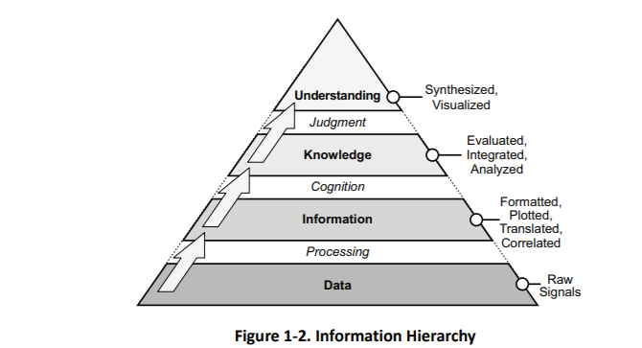

### Information

**Information as a Resource.** Information is one of the most precious resources available to any decision maker (JFACC, aircrew or controller). By nature, humans are information processors who seek knowledge of the past, present, and prospects for the future. Without valid information, decision makers have no logical basis for choosing one course of action over another. Increasing information generally decreases uncertainty in decision making, up to a point of diminishing returns, where too much information can confuse a situation. In a sense, information is like fire insurance. It has little value until it is needed, but then it is invaluable.

**Sources of Information.** Information can take many forms and be derived from many sources. Information can result from observing or reporting an event. It can be derived from the manipulation of facts through computation. It can also result from professional opinions, judgments, and interpretations by participants. Information may be objective or subjective. Usually, it comes from a combination of sources and is a presentation of both fact and insight.

**Characteristics of Information.** Information has many characteristics and does not come without cost. Acquiring sufficient, accurate, and timely information can be very expensive. It can be perishable and is generally imperfect. Consequently, information from one source should be verified with another source whenever possible. Frequently, information derived from one source can be used as a cue in researching other sources or in collecting additional or different information. Information can be acquired through various methods. Each has advantages, and all have inherent and environmental limitations and constraints. The observer, as a source of information, is often biased. Observers are also limited by what can be seen. Since it is difficult to observe an elaborate and dynamic system, the tendency is to “freeze” the situation and examine individual system parts in a static state. In doing so, essential ingredients are frequently lost. There is often the danger of attributing a great degree of precision to imperfect assessments or measurements. Because of these many limitations, information varies in validity and reliability.

**~~Information Threshold.~~** ~~The information threshold is that point in time when one has accumulated enough information to make a valid decision. In theory, one should keep collecting information until the information threshold or the point of adequacy is reached. As figure 2.1 suggests, independent information sources 1, 2, and 3 do not provide sufficient information to reach the threshold. But when information from all three sources is combined, the threshold is reached and the point of diminishing returns (that is, when the additional information costs more to collect than the value gained from having it) is reached. Keep in mind that the point of adequacy for information is adjustable depending on the fidelity of information needed. If the various portions are viewed as an “information budget”, the information threshold and collection resources can be managed accordingly.~~

### Intelligence

**Intelligence Processing**. Since information does not present itself for exploitation, it must be sought, gathered, assembled, and processed into usable form. The outcome is the transformation of raw information into intelligence suitable for making valid decisions. Intelligence is required for both planning campaigns (JFACC) and for planning and conducting tactical operations (JFACC, aircrew and controllers).

~~There are three levels of intelligence support: strategic, operational, and tactical. Strategic intelligence is required for the formulation of strategy, policy, and military plans and operations at national and theater levels. Operational intelligence is required for planning and conducting campaigns and major operations to accomplish objectives within theaters or areas of operations. Tactical intelligence is required for planning and conducting tactical operations.~~ Intelligence sources are the means or systems used to observe, sense and record, or convey information. There are seven primary intelligence source types: imagery, human, signals, measurement and signature, open source, technical, and counterintelligence.

The overall objective of intelligence is to enable commanders and combat forces to “know the enemy” and operate smarter. It helps commanders across the range of military operations by collecting, analyzing, fusing, tailoring, and disseminating intelligence to the right place at the right time for key decision making. Intelligence provides indications of enemy intentions and guides decisions on how, when, and where to engage enemy forces to achieve the commander’s objectives. It assists in combat assessment through munitions-effects assessment and bomb-damage assessment

Intelligence organizations integrate technical and quantitative assessments with analytical judgments based on detailed knowledge of the way the enemy thinks and operates. Intelligence personnel should maintain an independent perspective. Commanders anticipate that even the best intelligence may not provide a complete picture, especially when the enemy is practicing deception or when the intelligence is derived from a single source. Still, intelligence gives commanders the best available estimate of enemy capabilities, COGs, and courses of action.

### Intelligence cycle

Intelligence provides clear, brief, relevant, and timely analysis on enemy capabilities and intentions for planning and conducting military operations. The intelligence community uses the intelligence cycle which is broken down into five separate categories or steps.

The intelligence cycle is defined as: “*the steps by which information is converted into intelligence and made available to users*”. The five steps in the cycle are:

* **Planning and direction**: determination of intelligence requirements, preparation of a collection plan, issuance of orders and requests to information collection agencies~~, and a continuous check on the productivity of collection agencies.~~
* **Collection:** acquisition of information and the provision of this information to processing and/or production elements.
* **Processing:** conversion of collected information into a form suitable to the production of intelligence.
* **Production**: conversion of information into intelligence through the integration, analysis, evaluation, and interpretation of all source data and the preparation of intelligence products in support of known or anticipated user requirements.
* **Dissemination**: conveyance of intelligence to users in a suitable form.

~~Interaction with Air tasking Cycle~~

~~Stage 1: Objectives and effects. Directions & Guidance (Planning and direction)~~

~~Stage 2: Targeting, weaponeering, MAAP and AOD (processing production)~~

~~Stage 3: ATO and ACO production (dissemination)~~

~~Stage 4: Execution (collection)~~

#### Planning and direction

The first phase in the intelligence cycle is planning and direction. This phase consists of the identification of intelligence requirements and the planning of intelligence operations and activities to satisfy those requirements. JFACC directs the intelligence effort; VIS manages this effort for JFACC. In so doing, the VIS is guided by the JFACC's intent, the established priority intelligence requirements, and specific guidance provided by JFACC for the conduct of the intelligence effort. Planning and direction encompass the supervision of collection, processing, production, and dissemination operations as well as developing the intelligence structure necessary to support planned or ongoing operations.

#### Collection

Collection is the second phase of the intelligence cycle. During collection, organic, attached, and supporting intelligence sources collect and deliver information to the appropriate processing or production unit—or, in some instances, directly to the appropriate commander for immediate action. Effective collection depends upon the use of a variety of mutually reinforcing sources. Necessary, planned redundancy and overlap of sources increase the reliability of information and can reduce the effectiveness of enemy deception or denial efforts.

#### Processing and exploitation

Processing and exploitation are the third phase of the intelligence cycle, the conversion of raw data into a form suitable to produce intelligence. Largely a technical function, processing and exploitation converts the data into an understandable form and enhances its presentation. Examples of processing and exploitation include developing and interpreting a piece of film, translating a foreign-language text, or decoding an encrypted radio report. Not all information requires processing; some is collected in a form already suitable for production. Sometimes processing and exploitation occurs automatically during collection.

Registering in log for 132nd

#### Production

The fourth phase of the intelligence cycle is production, the activities by which processed data is converted into intelligence. Production involves evaluating the pertinence, reliability, and accuracy of information. It involves analyzing information to isolate significant elements. It includes integrating all relevant information to combine and compare those elements of information with other known information.

Finally, production involves interpreting the information to form logical conclusions that bear on the situation and that support the commander's plan to engage the enemy. Production is a process of synthesis—the most important action in developing usable intelligence for the commander. Production arranges the intelligence pieces to form coherent images. It is this step which adds meaning to these pieces, creating knowledge. Synthesis does not generally create a complete image—totally filling in the gaps and eliminating uncertainty— but it should provide an image from which the commander can reach an acceptable level of understanding. In the end, synthesis answers the all-important question: "What effect does all of this have on our ability to accomplish the mission?"

#### Dissemination

The fifth phase of the intelligence cycle is dissemination, the timely conveyance of intelligence in an appropriate form and by a suitable means to those who need it. Depending on its importance and time-sensitivity, intelligence may be disseminated—" pushed"——directly to users, or it can be sent to an accessible data base from which commanders can "pull" that intelligence which they need (see figure 3). Intelligence flows by any number of channels or methods. The form intelligence takes can influence dissemination. Some intelligence can be transmitted almost instantaneously to multiple users via a digital communications link, while other intelligence must be physically delivered by courier. The channel or means of dissemination is less important than the arrival of the intelligence at the proper destination on time and in a form readily usable to the commander. Depending on the urgency and time-sensitivity of the intelligence, it may follow established communications channels, or it may be broadcast to the entire force simultaneously as an alert or alarm.

The final phase in the intelligence cycle is utilization. The commander may provide direction, information may be collected and converted into intelligence, and the intelligence may be disseminated, but unless that intelligence is exploited through decision and action, it has served no purpose. Utilization is not a function of intelligence per Se, but rather of command and control—making the decision and then carrying it out. This reinforces two important points made earlier: first, intelligence has no value for its own sake but assumes value only when acted upon; and secondly, intelligence is inextricably linked to command and control.

No one phase of the intelligence cycle is more important than the others—they are interdependent. Without proper direction, the other phases will be uncoordinated and ineffective. Without effective collection, there may be too much or too little information, and the information obtained may prove irrelevant. Without processing and production, the resulting mass of information may appear meaningless. Lengthening production time will delay dissemination. The first four phases of the intelligence cycle offer marginal value unless the intelligence arrives to the right person in time and in a useful form to support decision-making. Finally, intelligence operations are wasted if commanders fail to understand and act upon the knowledge intelligence offers. For simplicity, the intelligence cycle is described as a sequential method; however, in practice, it is a dynamic process responsive to changes in the situation and the commander's evolving intelligence needs.

### Intelligence Collection

VIS intelligence effort begins with receipt of the mission and the CJTF/JFACC's guidance. On-hand intelligence is rarely sufficient to support comprehensive planning and decision-making needs and gaps will remain. Such intelligence gaps are known as intelligence requirements (IR).

Intelligence requirements (IR) are questions about the enemy and the environment, the answers to which JFACC, aircrew or controllers requires to make sound decisions. The breadth of potential intelligence gaps, however, will generally far exceed intelligence capabilities available. Thus, it is important to focus intelligence operations on those intelligence requirements crucial to mission success. We call these requirements priority intelligence requirements (PIR).

Priority intelligence requirements (PIRs) are intelligence requirements associated with a decision that will critically affect the overall success of the command's mission. Priority intelligence requirements constitute JFACC’s guidance for the intelligence collection, production, and dissemination efforts. The nature and scope of intelligence requirements will vary with the level of command and its mission. Further, the type of operation and at what particular phase of planning or execution the commander states a requirement will be major influences on its breadth and complexity. However, it is the commander who designates the priority intelligence requirements and therefore provides direction to the intelligence effort.

Collection management (CM) is defined as “In intelligence usage, the process of converting intelligence requirements into collection requirements, establishing, tasking or coordinating with appropriate collection sources or agencies, monitoring results and retasking, as required.” The CM process is a staff activity that is focused on decisions and choices that concern collection requests (CRs) and requests for information (RFI). Such requests may originate from the unit commander, the operations staff, or the intelligence staff. They may also be levied by external organizations, such as theater headquarters, a joint task force headquarters, as well as lateral and subordinate units. The source and scope of levied requirements are typically related to the collection capabilities or tasking/requesting authority of a given unit. There are a variety of ways to task the intelligence system to gain needed information for operational use. A myriad of collectors, ranging from humans to airborne collectors that are controlled manually or are software-driven, are tasked to fulfill intelligence requirements. It is the responsibility of intelligence support personnel at the unit level to accurately determine the direction and flow of intelligence information. Intelligence needs, referred to as requirements, are registered based on time sensitivity. Requirement’s definitions, as they apply to the air operation, are as follows:

* Time Critical Requirements - Requester needs in less than 24 hours, tactical in nature. Missions already employed or alert assets will usually be tasked (e.g., request for the location of a SCUD TEL that has recently launched a missile is a fleeting requirement).
* Routine Requirements - Requester needs in 24 hours or more, supports routine combat operations. Will be addressed through the collections process (e.g., creation of collection targets to search for specific enemy units that have not yet been located in the AOR).
* Standing Requirements - Established before a contingency arises and provides a baseline for the intelligence problem set (i.e., request to monitor airfields for operational activity).

The objective of the CM process is to satisfy the commander's essential elements of information (EEIs). These are necessary to accomplish the given mission and assigned operational tasks. The collection manager is a central figure of the process, serving to coordinate and facilitate the activities of two cyclic, mutually supporting functions: the translation and development of taskings, referred to as Collection Requirement Management (CRM), and the employment of intelligence collection resources, known as Collection Operations Management (COM). The two functions are structured to support the operational commander's mission statement in a responsive manner (figure 2.2).

IR eller RFI

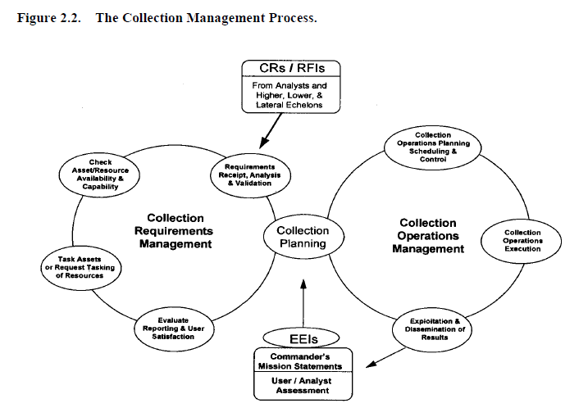

Intelligence gaps or information needs are formally labeled intelligence requirements (IR). An intelligence requirement is any subject, general or specific, upon which there is a need for the collection of information, or the production of intelligence.

PIRs are those intelligence requirements for which a commander has an anticipated and stated priority in the task of planning and decision-making. ~~In Marine Corps usage, an intelligence requirement associated with a decision that will critically affect the overall success of the command’s mission (MCRP 5-12C).~~ PIRs are prioritized among themselves and may change in priority over the course of an evolution. Only the commander designates PIRs.

Generally, the difference between a PIR and an IR is that a commander must have the answer to the PIR to make a decision. At any one time there are not many PIRs in effect.

The lowest priority PIR takes precedence over the highest priority IR. IRs are questions typically generated by the staff but not ones that the commander feels he needs answered before making decisions. While there are ideally a few PIRs, there may be many IRs. Like PIRs, IRs should be prioritized against each other to support effective intelligence planning and operations. PIRs and IRs have the following characteristics.

Each PIR or IR:

* Asks only one question.
* Focuses on specific facts, events or activities concerning the enemy or the battlespace.
* Is tied to mission planning, decision-making, and execution.
* Provides a clear, concise statement of what intelligence is required.
* Contains geographic and time elements to limit the scope of the requirement.

## Intelligence Preparation of the Battlefield (IPB)

Intelligence preparation of the battlespace (IPB) is a four-step systematic process of analyzing the threat and environment to help the JFACC better understand the many variables that can influence the mission and operations. ~~The IPB methodology is an effective analytical process that can be used during peacetime, crisis, or at the tactical, operational, and strategic levels of war. While most of the individual actions that constitute IPB are nothing new to Air Force intelligence, establishing a consistent process will provide greater focus, thereby improving the overall effectiveness of aerospace power.~~

Specifically, IPB focuses on the relationship between the threat and environment, along with the effect of that interaction on both friendly and enemy courses of action. IPB results in the production of enemy courses of action, named areas of interest, and high-value targets, which are inputs to the JFACC campaign planning, intelligence collection, and targeting processes. When done properly, IPB facilitates getting “inside” the enemy’s decision-making cycle~~. IPB is viewed by the US Air Force as a valuable methodology for focusing intelligence on the commander and the commanders’ supporting C2 elements. Additional advantages include integrating analysis, collection management, and targeting processes, as well as providing a standardized analytic approach for training purposes. Air Force intelligence entities at all levels of command should use IPB principles, focusing on environmental and threat characteristics and activities that significantly influence air, space, and information operations. However, specific IPB products and procedures are left to the discretion of local commanders.~~

## Combat Assessment

**Combat Assessment.** Effective campaign planning demands a continuing evaluation of the effect of operations on the campaign plan. While the JFC directs the overall combat assessment (CA), the JFACC provides the necessary expertise to assess ongoing air operations. In this respect the JFACC continuously evaluates the results of his operations and provides his assessments to the JFC who consolidates and evaluates the overall campaign. The JFACC’s CA plan incorporates Battle Damage Assessment (BDA), Munitions Effectiveness Assessment (MEA), and recommendations for re-strikes. The CA plan also considers the forces employed, munitions, timing of attacks, and the effects of specific attacks against enemy targets and remaining capabilities. As the cycle continues, the JFACC analyses remaining enemy capabilities and determines the enemy’s likely courses of action, all the while balancing targeting priorities and overall targeting efforts. The JFC is always ‘kept in the loop’.

## ~~Duties~~

~~Intelligence officer~~

~~The intelligence officer synchronizes the information collection plan and provides information on the~~

~~current enemy situation as well as provides estimates as to what the enemy is capable of doing in the future.~~

~~The intelligence officer provides assessments of probable enemy actions, analyzes, and identifies targets~~

~~based on the commander's guidance. The intelligence officer duties include:~~

~~ Develop and provide IPB products to the other targeting working group members.~~

~~ Develop and refine HVTs.~~

~~ Pass HPTs and suspected HPTs to the fires cell.~~

~~ Develop and refine HPT data.~~

~~ Develop, monitor, and refine the HPTL, AGM, and BDA requirements with other members of~~

~~the targeting working group.~~

~~ Distribute the information collection plan to collection managers.~~

~~ Provide input to the fires cell on target selection standards.~~

~~ Periodically reassess the HPTL, AGM, and BDA requirements with the operations plans and~~

~~operations officer.~~

~~ Receive BDA and, with the deputy fire support coordinator, determines if an attack achieved the~~

~~desired effects or if additional attacks are required.~~

~~ Provide input for the decision support template.~~

~~The intelligence operations officer's actions follow:~~

~~ Maintain the target database.~~

~~ Evaluate and analyze combat information with the FAIO to identify HVTs and recommend~~

~~HPTs.~~

~~ Apply the criteria for timeliness and accuracy from the target selection standards.~~

~~ Report HPTs to the FAIO.~~

~~ Recommend NAI and TAI to the intelligence officer to support targeting.~~

~~ Coordinate with the collection manager to ensure adequate intelligence collection to support~~

~~targeting.~~

~~Brigade intelligence officer:~~

~~The S-2 is responsible for preparing the information collection plan and maintaining information on the~~

~~current enemy situation. He provides assessment of possible enemy actions, provides analyses, and identifies~~

~~targets based on the BCT commander’s guidance. Specific targeting responsibilities include:~~

~~ Developing target arrays.~~

~~ Providing enemy capabilities and projected courses of action.~~

~~ Providing IPB products to the targeting working group and targeting board.~~

~~ Developing high-value targets (HVT).~~

~~ Determining with the brigade targeting officer which HPTs can be acquired with organic assets.~~

~~ Developing support requests for acquiring high-payoff targets beyond the capabilities of organic~~

~~assets.~~

~~ Coordinating the collection and dissemination of targeting information with the targeting officers in~~

~~the fires cell.~~

~~ Developing and supervising implementation of the information collection plan.~~

~~ Advising the operations officer about assessment collection capabilities.~~

~~ Coordinating with the brigade FSO for indirect fires to support the information collection plan.~~

Intelligence cycle

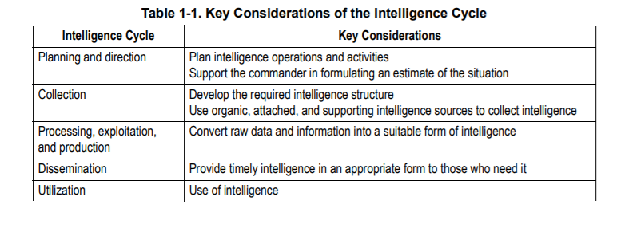

## Targeting

Targeting recommends the best means to attain a goal. It integrates intelligence information

about the threat, the target system, and target characteristics with operations data on friendly force posture, capabilities, weapons effects, objectives, rules of engagement, and doctrine. Targeting matches objectives and guidance with inputs from intelligence and operations to identify the forces necessary to achieve the objectives

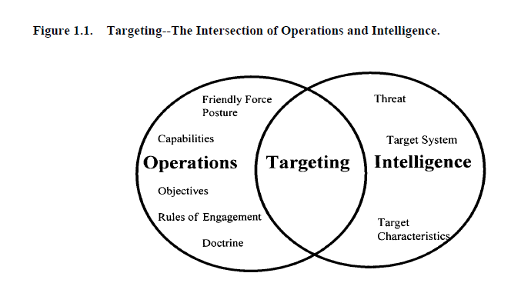

The targeting process is an analytical, systematic approach that focuses targeting efforts on

supporting operational planning and facilitates force employment. A model has been constructed that centers around six phases considered the framework for the targeting process (figure 1.2). This chapter will briefly describe each step in this theoretical construct; later chapters will describe the specifics involved in each step. The six steps of the targeting process are:

• Objectives and guidance derivation

• Target development

• Weaponeering

• Force application

• Execution planning

• Combat assessment

**5.3. Targeting Process Phases.**

**1.5.3.1. Objectives and Guidance Derivation** . Objectives and guidance are the foundation of

the targeting process. In this phase, the objectives and guidance are developed and disseminated

to the targeteer. Objectives are developed at the national, theater, and component levels. Guidance

is generally provided at the National and war fighting CINC-level. Both objectives and guidance

must be quantifiable and unambiguous in order to be effective.

**1.5.3.2. Target Development.** This is the examination of potential target systems and their components

to determine change to system criticality and vulnerability to attack. This phase distills

the commander's objectives into lists of targets. The product of this phase is a suggested target list

with recommended priorities assigned and extent of desired damage.

**1.5.3.3. Weaponeering Assessment.** In this part of the process, planners assess the types and

quantity of weapons estimated to achieve a desired level of damage to the individual targets. The

product of this phase is a list of recommended weapons and aircraft for each target and a validated

list of weapon impact points for each target. Weaponeering takes into account target vulnerabili10

ties, weapons effects and reliability, delivery accuracy, delivery conditions, as well as damage criteria.

**1.5.3.4. Force Application.** The force application phase uses the information generated in the

target development and weaponeering assessment phases to determine the best force necessary to

meet operational objectives. At this point, the decision maker is provided with fused intelligence

on the target and weapon systems recommendations. It is here that operations and intelligence

merge their planning efforts to meet the CINC’s guidance.

**1.5.3.5. Execution Planning.** Execution planning prepares input for and supports the actual tasking,

construction, and subsequent execution by weapon systems. Input includes data concerning

the target, weaponeering calculations, employment parameters, and tactics. The operational command

is responsible for monitoring the ATO/ITO, making any changes necessary and providing

support to the units. Under Air Force doctrine of centralized control, decentralized execution, unit

commanders are given the freedom and flexibility to execute the plan, as they see fit.

**1.5.3.6. Combat Assessment.** After mission execution, the quality of the whole process is

assessed. Improvements in force employment, munitions design and situation assessments

emerge from this appraisal of post-strike data. The results of this effort affect future combat operations

and can change theater objectives. The product of this phase is tailored to the decision makers.

‘

THE TARGETING PROCESS

3.1. Overview. The targeting process is a conceptual construct used to explain how targeting is performed. The process is performed at various levels of command and execution. Though driven by intelligence, it is not the purview of any one community. Community boundaries are beginning to blur between operations and intelligence. This should help consolidate targeting functions. The targeting process includes actions that produce target intelligence and target materials (through analysis and fusion of multi-source intelligence) and applied in support of operational decision making and force employment.

This process includes the steps by which targets are recommended and is comprised of six phases:

• Objectives and guidance derivation

• Target development

• Weaponeering

• Force application

• Execution planning

• Combat assessment

3.1.1. These phases are bi-directional and iterative. Often, they overlap and targeteers perform several of them simultaneously.

3.2. Phases of the Targeting Process.

3.2.1. **Objectives and Guidance Derivation** . Objectives and guidance derivation comprise the

foundation of the targeting process, originating at the national level and becoming more specific and dynamic at progressively lower echelons of command. Unified command objectives establish priorities for targeting, damage criteria, and restrictions on force employment. Guidance includes principles of war, the international Law of Armed Conflict (LOAC), and established rules of engagement. Objective and guidance should be clear and unambiguous so as to be interpretable at the lowest level of command. The necessary first step as a targeteer is to understand objectives and guidance to provide correct targeting advice to commanders. (Within an Air Force AOC, objectives and guidance will normally come from the Strategy Division.)

3.2.2. **Target Development** . During target development, a planner analyzes a potential target system and its components to estimate the commander’s best course of action to achieve a given objective. All-source intelligence data bases are reviewed and potential target systems and targets are selected for consideration. A subset of target development is target analysis, which examines potential targets to determine military importance, priority of attack, and weapon feasibility to obtain a desired level of damage, casualties or to achieve the desired effect. The selected target systems are then further analyzed to determine their components and critical elements. A priority listing of these critical elements is used for weaponeering assessment. Target development includes validation of the target and nomination to the appropriate authority.

3.2.3. **Weaponeering** . The output of weaponeering is a recommendation of the quantity, type, and mix of lethal and non lethal weapons needed to achieve a probable level of target damage or effects while avoiding unacceptable collateral damage. It is important to note weaponeering results are probabilistic and not predictive. Considerations are:

• Target vulnerability

• Weapon effects

• Munitions delivery errors

• Delivery tactics

• Damage criteria

• Probability of kill

• Weapon reliability

3.2.4. **Force Application.** Force application planning is the fusion of target nominations with the

optimum available lethal and non lethal force. In this phase, forces are analyzed to determine likely results to be achieved against target systems and their activities. For lethal force, this is based on probabilities of damage and arrival for a weapon system. For non lethal force this is based on the expected outcome (consequences). The result of force application is a strike package nomination for the commander's approval that has coordinated recommendations from operations, plans, and intelligence. This includes actions in preparation for attack once force selection recommendations are approved. Targeteers prepare the target intelligence portion of plans and assist in air tasking order (ATO) preparation.

3.2.4.1. During force selection, targeting analysts work closely with operators and planners to

match targets with available weapon systems, munitions, and possible non lethal force options.

Force sizing is then optimized in light of available resources and other constraints.

3.2.4.2. Targeteers also assist in attrition analysis or calculations for potential friendly force losses to enemy defenses. Attrition analysis bears on both delivery tactics and optimal force sizing.

3.2.5. **Execution Planning** . Execution planning is the more detailed planning required to actually fly the mission and employ weapons. It is both a component and unit function. At the air operations center (AOC), preparation for the execution of the ATO entails review of plans, weather, logistics, and current situation. At the unit level, it involves mission planning. Unit functions for targeteers have evolved with the automation of mission planning tools, and the laborious work of hand drawn radar predictions, old mensuration tools, and slide rule weaponeering is approaching an end. With a single Air Force-wide intelligence tool (Combat Intelligence System) and a single mission planning tool (Air Force Mission Support System), we have begun to standardize targeting tasks and ease training problems.

3.2.5.1. Targeteers provide the approved targets list, weaponeering, and target materials, such as

maps, charts, mensurated coordinates, and imagery. They assist operators in selecting mission

routing, axis of attack, aimpoints, and fuze settings.

3.2.5.2. Targeting planners also prepare mission folders containing charts (annotated with ingress and egress routing, and aimpoints), strip charts, threat data, and battle damage assessment (BDA) reporting guidelines.

3.2.6. **Combat Assessment** . Effective campaign planning and execution require a continuing evaluation of the impact of joint force combat operations on the overall campaign. Combat assessment (CA) evaluates combat operations effectiveness in achieving command objectives and recommends changes to tactics, strategies, objectives, and guidance. It has several sub assessments including mission assessment (MA), battle damage assessment (BDA), and munitions effectiveness assessment (MEA). The military end state, as written in the campaign estimate and modified during an operation, is directly linked with CA. CA compares the results of the operation to the objectives to determine mission success or failure within the guidance parameters. More important than a review, it looks forward to determine if additional missions are needed and/or if modification to the objectives is necessary. Combat assessment is one concept with many implementations.

A target is

1. An entity or object that performs a function for the adversary considered for possible engagement or other action.

2. In intelligence usage, a country, area, installation, agency, or person against which intelligence operations are directed.

3. An area designated and numbered for future firing.

4. In gunfire support usage, an impact burst that hits the target (joint publication [JP] 3-60).

Targets include mobile and stationary forces, equipment, and facilities that an enemy commander can use to conduct operations. Targeting is the process of selecting and prioritizing targets and matching the appropriate response to them considering operational requirements and capabilities (JP 3-0). The emphasis of targeting is on identifying enemy resources (targets) that if destroyed or degraded will contribute to the success of the friendly commander’s mission.

The expected results of a successful attack eliminating a resource begin to place limits on the enemy commander’s available tactical options.

Targeting personnel identify critical target subsets that when successfully acquired and

attacked significantly diminish enemy capabilities. Denying critical resources to the enemy

makes him vulnerable and expands friendly opportunities for success in battle. Successful

targeting requires that the commander synchronize information related capabilities, intelligence, maneuver, fire support systems, nonlethal effects, and special operations forces to attack and eliminate critical target(s) using the most effective system in the right time and place. Targeting is a complex and multidiscipline effort that requires coordinated interaction among many command and staff elements.

The functional elements necessary for effective collaboration are represented in the targeting working group. A working group is a grouping of predetermined staff representatives who meet to provide analysis, coordinate and provide recommendations for a particular purpose or function (FM 6-0). These representatives include, but are not limited to, the fires, intelligence, current operations, future operations, and plans cells. Representatives from these cells are essential to the execution of targeting. Other members of the staff may help them in the planning and execution phases of targeting. Close coordination among all cells is crucial for a successful targeting effort. Sensors and collection capabilities under the control of external agencies must be closely coordinated and carefully integrated into the execution of attacks especially those involving rapidly moving, fleeting, or dangerous targets. In addition, the appropriate means and munitions must attack the vulnerabilities of different types of targets.

The enemy presents a large number of targets that must be engaged with available intelligence,

acquisition, and attack assets. The targeting process weighs the benefits and the cost of engaging various

targets in order to determine which targets, if engaged, are most likely to contribute to achieving the desired

end state. Adhering to the five targeting guidelines should increase the probability of creating desired

effects while diminishing undesired or adverse collateral effects. These guidelines are:

● Targeting focuses on achieving the commander’s objectives. It is the function of targeting to

achieve efficiently those objectives within the parameters set at the operational level, directed

limitations, the rules of engagement, or rules for the use of force, the law of war, and other

guidance given by the commander. Every target nominated must contribute to attaining the

commander’s objectives.

● Targeting seeks to create specific desired effects through lethal and nonlethal actions. Target

analysis encompasses all possible means to create desired effects, drawing from all available

capabilities. The art of targeting seeks to create desired effects with the least risk and

expenditure of time and resources.

● Targeting directs lethal and nonlethal actions to create desired effects.

● Targeting is a fundamental task of the fires warfighting function that encompasses many

disciplines and requires participation from many staff elements and components.

● Targeting creates effects systematically. A targeting methodology is a rational and iterative

process that methodically analyzes, prioritizes, and assigns assets against targets systematically

to create those effects that will contribute to achieving the commander’s objectives. If the

desired effects are not created, targets may be considered again in the process or operations may

have to be modified.

**TIME-SENSITIVE TARGETS**

1-16. A *time-sensitive target* is a joint force commander validated target or set of targets requiring

immediate response because it is a highly lucrative, fleeting target of opportunity or it poses (or will soon

pose) a danger to friendly forces (JP 3-60). A time-sensitive target (TST) is a joint force commander

(JFC) designated target or target type of such high importance to the accomplishment of the JFC mission

**1-4 ATP 3-60 7 May 2015**

**Target Guidelines and Philosophy**

and objectives or one that presents such a significant strategic or operational threat to friendly forces or

allies, that the JFC dedicates intelligence collection and attack assets to ensure success.

1-17. TSTs comprise a very small or limited number of planned targets due to the required investment of

assets and potential disruption of planned execution, and are only those targets designated by the JFC and

identified as such in the JFC guidance and intent. TSTs are normally executed dynamically; however, to be

targeted successfully, they require considerable deliberate planning and preparation within the joint

targeting cycle.

1-18. Service component

**D3A IN MILITARY DECISIONMAKING PROCESS**

1-22. The decide function coincides with the MDMP from the receipt of mission through the issuing of the

approved plan or order. The detect function is a continuing function that starts with the commanders

approval of the plan or order and is accomplished during execution of the plan or order. Once detected,

targets are attacked and assessed as required. Targeting working groups are used as a vehicle to focus the

targeting process within specified time.

1-23. D3A methodology functions occur simultaneously and sequentially during the operations process.

Decisions are made during the planning of future operations. Current operations simultaneously detect,

deliver, and assess targets based on current targeting decisions.

**Decide**

1-24. The decide function is the most important and requires close interaction between the commander and

the intelligence, plans, operations, fires cell, and servicing judge advocate. The staff officers must clearly

understand the following:

● Unit mission.

● Threat vulnerabilities.

● Commander’s intent.

● Commander’s planning guidance.

● Rules of engagement.

1-25. With this information, the staff officers can prepare their respective running estimates. From the

standpoint of targeting–the fire support, intelligence, information related capabilities, and operations

estimates are interrelated and closely coordinated among each cell. Key staff products include target value

analysis and the intelligence estimate from the targeting and intelligence officers. War gaming allows the

deputy fire support coordinator (DFSCOORD) or fire support officer (FSO) to develop the decide function

products.

**7 May 2015 ATP 3-60 1-7**

**Chapter 1**

**Detect**

1-26. The detect function is conducted during the execution of the OPORD. Target acquisition assets

gather information and report their findings back to their controlling headquarters, which in turn pass

pertinent information to the tasking agency. Some collection assets provide actual targets, while other

assets must have their information processed to produce valid targets. Not all of the information reported

would benefit the targeting effort, but it may be valuable to the development of the overall situation. The

target priorities developed in the decide function are used to expedite the processing of targets. Situations

arise when the engagement, upon location and identification, of a target is either impossible (for example

out of range) or undesirable (outside of but moving toward an advantageous location for the attack).

Critical targets that we cannot or choose not to attack in accordance with the attack guidance should be

tracked to ensure they are not lost. Tracking suspected targets expedites execution of the attack guidance.

Tracking suspected targets keeps them in view while they are validated. Planners and executers must keep

in mind that assets used for target tracking may be unavailable for target acquisition.

**Deliver**

1-27. The deliver function’s main objective is to attack targets in accordance with the attack guidance

provided. The tactical solution (the selection of a weapon system or a combination of weapons systems)

leads to a technical solution for the selected weapon. The technical solution includes the following:

● Specific attack unit.

● Type of ordnance.

● Time of attack.

● Coordinating instructions.

**Assess**

1-28. Commanders continuously assess the operational environment and the progress of operations, and

compare them to their initial vision and intent. Commanders adjust operations based on their assessment to

ensure objectives are met and the military end state is achieved. The commander and his staff assess the

results of mission execution. If combat assessment reveals that the commander’s guidance or conditions of

operational success have not been met, detect and deliver functions of the targeting process must continue

to focus on the targets involved.

1-29. The assessment process is continuous and directly tied to the commander’s decisions throughout

planning, preparation, and execution of operations. Staffs assist the commander by monitoring the

numerous aspects that can influence the outcome of operations and provide the commander timely

information needed for decisions. The commander’s critical information requirements are linked to the

assessment process by the commander’s need for timely information and recommendations to make

decisions. Planning for the assessment identifies key aspects of the operation that

**DECIDE**

2-6. The decide function begins the targeting cycle. This step provides the overall focus and sets priorities

and criteria for intelligence collection and engagement planning. The decide function draws heavily on the

staff’s knowledge of the enemy, (to include their tactics, culture, and ideology), a detailed intelligence

preparation of the battlefield (IPB), and continuous assessment of the situation. Targeting priorities must be

addressed for each phase or critical event of an operation. The decisions made are reflected in visual

products. The products are as follows:

● The *high-payoff target list* is a prioritized list of high-payoff targets by phase of the operation

(FM 3-09). A *high-payoff target* is a target whose loss to the enemy will significantly contribute

to the success of the friendly course of action (JP 3-60). A high-payoff target (HPT) is a highvalue

target (HVT) that must be acquired and successfully engaged for the success of the

friendly commander’s mission. A *high-value target* is a target the enemy commander requires

for the successful completion of the mission (JP 3-60).

● The Decide function helps build the information collection plan. HPTs are nearly always a

priority intelligence requirement (PIR).

● Target selection standards address accuracy or other specific criteria that must be met before

targets can be attacked.

● **The *attack guidance matrix* is a targeting product approved by the commander, which**

**addresses the how and when targets are engaged and the desired effects.**

**Prerequisite Information and Intelligence for Targeting**. To begin target planning the following information requirements should be addressed to prevent waste of resources.

Intelligence on Enemy Defensive and Offensive Posture, Capabilities, and Intentions. The targeteer must have current, accurate intelligence on the enemy's status and predisposition.

**Target System, Component, and Element Characteristics.** Targeteer’s must have current, accurate intelligence on the physical, functional, mobility, and environmental characteristics of potential enemy targets.

**Friendly Force Posture and Capabilities.** The targeteer should know what forces will be available for offensive operations and the capabilities of these forces. Care must be taken to prevent potential options from being overlooked because a capability is assumed not to be available. If a force capability not available at the beginning of an analysis can be demonstrated to be clearly superior, it may be possible to obtain the capability. In any event, targeting personnel should be aware of current and potential force capabilities and consider them during their analysis.

**Concept of Operations, Mission Objectives, and Rules of Engagement.** The targeteer must understand the concept of operations and mission objectives in order to conduct an analysis that results in target recommendations to achieve those objectives. They should remember that most offensive operations take place in a joint service environment. Consequently, the scheme of maneuver of other component forces should be known to make all systems effective, and the operation of the USAF component should be integrated as much as possible with them. Even though the Unified commander is responsible for integrating operations by the various service components, this can only happen in fact if the effort is made at the working level, during the basic planning.

For targeteer’s to function effectively, they must understand Air Force and Joint doctrine. Doctrine is important because it is based on the capabilities of the US military and states fundamental concepts upon which planning should be based.

### Support to Targeting

A target is an entity or object that performs a function for the threat considered for possible engagement or other action. (DOD Dictionary) Targeting is the process of selecting and prioritizing targets and matching the appropriate response to them, considering operational requirements and capabilities. During IPB steps three and four, the intelligence staff identifies high-value targets associated with each enemy capability or COA. This aids the fires cell as they conduct TSAs.

An example targeting model, decide, detect, deliver, and assess (also referred to as D3A) for the targeting process is as follows:

Decide:

* IPB supports identifying potential targets and entities through COG and critical vulnerability analysis. (Note: CARVER is a target analysis and vulnerability assessment framework— criticality, accessibility, recognizability, vulnerability, effect, and recuperability.)
* Intelligence prioritizes, develops, and nominates targets to include on appropriate target and engagement lists in coordination with operations.

Detect:

* Intelligence requirements are developed.
* Collection assets and resources are leveraged; the target or entity is acquired and tracked.

Deliver:

* Intelligence assesses the ability to create desired effects.
* Intelligence supports developing MOE.
* Intelligence supports collateral damage estimates and weaponeering for commander approval.

Assess:

* Intelligence supports BDA by identifying the functional, operational, and system effects of engaging the target or entity.
* Collection assets are leveraged to support collecting MOEs and measures of performance. Note: Additional targeting process models include find, fix, finish, exploit, analyze, and disseminate (referred to as F3EAD) and find, fix, track, target, engage, and assess (referred to as F2T2EA).

### CARVER TOOL

CRITICALITY

Criticality means target value. This is the primary consideration in targeting. A target is critical when its destruction or damage has a significant impact on military, political, or economic operations. Targets within a system must be considered in relation to other elements of the target system. The value of a target will change as the situation develops, requiring the use of the time-sensitive methods which respond to changing situations. For example, when one has few locomotives, railroad bridges may be less critical as targets; however, safeguarding bridges may be critical to maneuvering conventional forces which require use of such bridges.

ACCESSIBILITY

A target is accessible when an operational element can reach the target with sufficient personnel and equipment to accomplish its mission. A target can be accessible even if it requires the assistance of knowledgeable insiders. This assessment entails identifying and studying critical paths that the operational element must take to achieve its objectives, and measuring those things that aid or impede access.

RECOUPERABILITY

A target's recouperability is measured in time; that is, how long will it take to replace, repair, or bypass the destruction of or damage to the target? Recouperability varies with the sources and type of targeted components and the availability of spare parts availability.

VULNERABILITY

A target is vulnerable if the operational element has the means and expertise to successfully attack the target. When determining the vulnerability of a target, the scale of the critical component needs to be compared with the capability of the attacking element to destroy or damage it.

EFFECT

The effect of a target attack is a measure of possible military, political, economic, psychological, and sociological impacts at the target and beyond. This is closely related to the measure of target criticality. The type and magnitude of given effects desired will help planners select targets and target components for attack. Effect in this context addresses all significant effects, whether desired or not, that may result once the selected target component is attacked. Traditionally, this element has addressed the effect on the local population, but now there are broader considerations.

RECOGNIZABILITY

A target's recognizability is the degree to which it can be recognized by an operational element and intelligence collection and reconnaissance assets under varying conditions. Weather has an obvious and significant impact on visibility. Rain, snow, and ground fog may obscure observation. Road segments with sparse vegetation and adjacent high ground provide excellent conditions for good observation. Distance, light, and season must also be considered. Table C-1 is an example of a CARVER matrix tool.

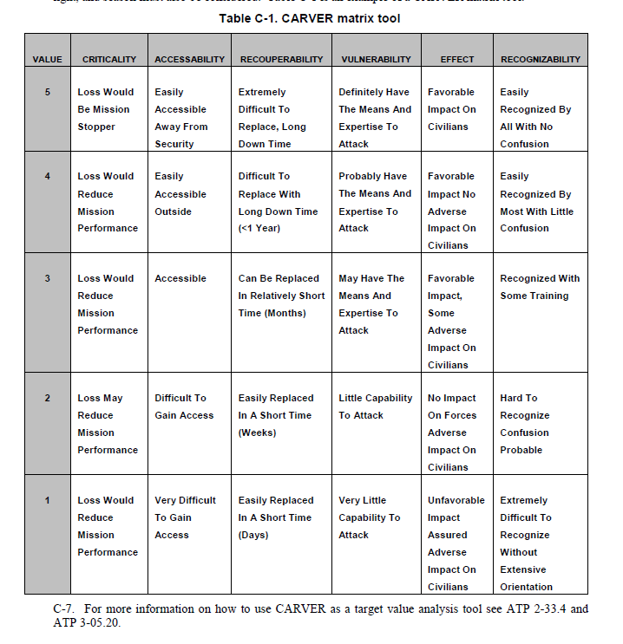

### Joint Target List (JTL)

### Joint Prioritized Target List (JPTL)

### BDA

**Battle Damage Assessment (BDA).** BDA is the timely and accurate estimate of damage resulting from the application of military force, either lethal or non lethal, against a predetermined objective. Battle damage assessment can be applied to the employment of all types of weapon systems (air, ground, naval, space, IW, and special forces) throughout the range of military operations. BDA is primarily an Intelligence responsibility with required inputs and coordination from Operations. Battle damage assessment is composed of physical damage assessment, functional damage assessment, and target system assessment (figure 9.2). BDA is the study of damage on a single target or set of targets. It is used for target study and target system analyses, reconstitution estimates, weaponeering, database updates, and for deciding restrikes. BDA was previously known in the air-to-surface arena as “bomb damage assessment” which still retains its own definition in JCS Pub 1-02. The BDA process answers the following questions:

• Did the weapons impact the target as planned?

• Did the weapons achieve the desired results and fulfill the objectives, and therefore purpose, of the attack?

• How long will it take enemy forces to repair damage and regain functionality?

• Can and will the enemy compensate for the actual damage through substitution?

• Are restrikes necessary to inflict additional damage, to delay recovery efforts, or attack targets not successfully struck?

• What are the collateral effects on the target system as a whole, or on other target systems?

## Air Campaign planning

### IPB

IPB is a systematic, four step analytical methodology employed to reduce uncertainties concerning the adversary and to exploit or minimize environmental factors. It is a continuous process, which enables JFACC to visualize the full spectrum of adversary capabilities, potential centers of gravity (COG), and possible courses of action (COA) across all dimensions of the battlespace. IPB assists VIS personnel to identify facts and assumptions about the battlespace environment and the enemy. This facilitates planning and the development of JFACCs Concept of Operation. During execution, IPB provides the basis for intelligence direction and synchronization that supports JFACCs Concept of operation (formulated through the JAOP) by tying ISR collection and analysis efforts to key decision points.

A key difference between aerospace and surface warfare is aerospace forces can strike directly at key target sets that have strategic results, without having to go through the process of drawn-out attrition at the tactical level of war. Air Force platforms deploy globally and will often pursue strategic, operational, and tactical objectives with very little time separation. Within the Air Force context, intelligence personnel will probably not have the luxury of focusing their IPB on only one level of warfare. Finally, aerospace power is the dominant force employed by the United States against an adversary’s war making potential. To do this effectively, the Air Force IPB process must focus on carefully identifying and analyzing adversary COGs, as well as identifying adversary COAs traditionally associated with the IPB process. Air Force doctrine defines COGs as "Those characteristics, capabilities, or localities from which a military force, nation, or alliance derives its freedom of action, physical strength, or will to fight. They exist at the strategic, operational and tactical levels of war."7 Airmen must understand the adversary’s COGs, his potential and probable COAs, the interrelationships between them, and the adversary’s overall ability to conduct military operations, in order to facilitate effective aerospace planning and execution at the strategic and operational levels of warfare. Thus, while the processes will be very similar, there will be some significant differences in emphasis and approach.

The VIS IPB process consists of four basic steps:

1. Define the Battlespace Environment

2. Describe the Battlespace’s Effects

3. Evaluate the Adversary

4. Determine Adversary COAs

While the IPB process is sequential, it is also continuous and cyclical. It must be conducted before, during, and after an operation, and while planning for and executing other contingencies as they arise. With the acquisition of new information, intelligence staffs modify their assessments of the battlespace, the adversary, and all potential COGs and COAs.

#### Step One: Define the Battlespace Environment:

The first step of the IPB process focuses on defining the limits of the battlespace. This is done by determining and evaluating JFACC's assigned Area of Responsibility (AOR), area of interest (AI), and mission. The AOR is that portion of the battlespace in which military operations are conducted to accomplish a specific mission. The AI is that area of concern to the commander, including the area of influence, areas adjacent thereto, and extending into enemy territory to the objectives of current or planned operations. This area also includes areas occupied by enemy forces who could jeopardize the accomplishment of the mission. The AI is usually larger than the AOR.

The purpose of step one is to bound the intelligence problem and identify for further analysis specific features in the environment, activities within it, and the space where they exist that may influence available COAs or the commander’s decisions. Once the AOR and AI are defined, and mission objectives and desired end states are determined, the commander determines the time available for planning. Time available determines the level of IPB detail possible. Concurrently, the battlestaff analyzes existing information to highlight gaps for future intelligence collection and analysis to acquire the adversary and environmental data needed to complete the remaining steps of the IPB process at a level of detail sufficient to support the JFACC’s decision-making process.

**Step One Final Results:**

1. Preliminary priority intelligence requirements (PIR) delineating the scope and detail required for the mission being planned, which evolve as the IPB process develops.

2. The identification of significant battlespace characteristics affecting JFACC`s mission.

3. The identification of intelligence gaps and priorities, which also evolve as the IPB process develops.

4. An initial set of intelligence collection and production requirements that support further IPB analysis and the JFACC’s mission.

#### Step Two: Describe the Battlespace’s Effects.

The battlespace imposes constraints and provides opportunities to adversary and friendly forces that are crucial in predicting possible adversary COAs and developing friendly COAs. Step two’s purpose is to determine how the battlespace affects both threat and friendly operations. Step two is not solely an intelligence function. In some cases other functional areas provide the majority of this information. For example, Air Force Weather is responsible for collecting, analyzing, predicting, tailoring, and disseminating weather and space environmental data to command staffs and operators required to plan and execute the mission.

**Step Two Final Results:**

The final product(s) of step two are varied and may take several forms from simple briefings to complex computer-based battlespace simulations and visualizations. The result should be products that:

1. Depict the total environment’s effect on possible broad friendly and adversary COAs at the strategic and operational levels.

2. Depict the battlespace’s impact on friendly and adversary weapons systems at the tactical level.

TIME AND DISTANCE (FROM VARIOUS AIRBASES or large cities)

SLOC

ROADS

Mobility corridors

Avenue of approach (ground and air)

MOUNTAINS (BLIND ZONES)

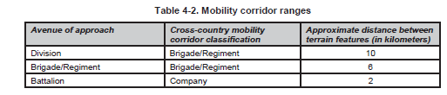

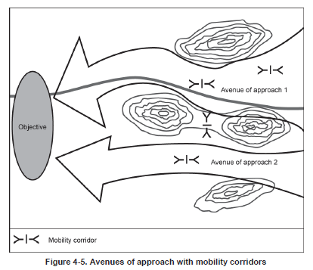

#### Step Three: Evaluate the Adversary.

The purpose of step three is to determine the adversary’s COGs, capabilities, doctrinal principles, and applicable tactics, techniques, and procedures (TTP). Step three also distills VIS knowledge of the adversary into specific intelligence products that succinctly communicate this information to JFACC and aircrew/controllers on events. This step involves:

1. Analyzing and identifying adversary COGs. (See JFACC TTP COG LINK)

2. Creating or updating threat models.

3. Determining the current adversary situation.

4. Identifying adversary capabilities.

**Centers of Gravity.** COG analysis is conducted after an understanding of the broad operational environment has been obtained and before a detailed study of the adversary’s fielded military forces occurs. The battlestaff analyzes leadership, resources, infrastructure, population, transportation systems, and internal and external relationships of the adversary to determine from which elements the adversary derives freedom of action, physical strength, or the will to fight. A determination is made if candidate COGs are truly critical to the enemy strategy and must include a thorough examination of the mechanisms by which COGs influence and affect enemy strategy. Once determined, COGs identified in this step are a significant input to the aerospace campaign plan and provide a foundation for target development.

**Threat Models.** Threat models describe and graphically portray threat tactics and employment options. They consist of three elements: 1) doctrinal templates, 2) description of preferred tactics, options, and follow on activities, and 3) identification of type high value targets (THVT). Doctrinal templates are "Graphic models based on known or postulated threat doctrine. Doctrinal templates illustrate the deployment pattern and disposition preferred by the adversary when not constrained by the effects of the battlespace environment."11 See Figure 4 for an example of a doctrinal template. THVTs are "Assets or target systems the adversary commander requires for the successful completion of the activity described as part of the threat model."12 THVTs are not "real" targets per se (e.g., an actual facility with a BE number). Rather, they simply describe what is important for execution of the activity being depicted. Later, in step four of the IPB process, these threat models are modified to reflect constraints imposed by the battlespace upon the adversary’s preferred method of operations. In addition to a graphical depiction, threat models are accompanied by textural information that describes the activities noted on the template, likely alternatives if the depicted activity fails (branches) or subsequent operations if the activity succeeds (sequels). Finally, threat models conclude by identifying and ranking the relative importance of THVTs.

**Current Adversary Situation.** The intelligence analyst determines the current adversary situation through a careful and detailed analysis of relevant order of battle (OB) data including force strength, composition, and disposition as well as observed TTPs and current training activities.

**Adversary Capabilities.** The intelligence staff then combines quantitative OB analysis with a qualitative assessment of the adversary’s readiness, training, and effectiveness to develop a complete picture of adversary capabilities. Comparing the current adversary situation with threat models highlights current strengths and weaknesses.

Step Three Final Results:

1. A listing of adversary COGs.

2. Graphic threat models. (SAM rings, altitude distance. Aircraft A-A missile threats DOR/MAR etc). Range rings for Artillery, rocket artillery, MLRS, SCUDs)

3. A prioritized listing of THVTs for various adversary operations.

4. A definitive and current adversary OB (Ground and Air excel spreadsheet).

5. A qualitative assessment of the adversary’s current capabilities, strengths, and weaknesses.

#### Step Four: Determine Adversary Courses of Action.

This step identifies, develops, and prioritizes adversary COAs consistent with the COGs developed in step three, the adversary’s doctrine, and their assessed political/military objectives. Step four’s purpose is to identify likely adversary COAs that can be exploited to shape the battlespace and accomplish the friendly mission. Crucial to this step is the identification of associated high value targets (HVT) that the adversary must preserve in order to execute their intended COAs and named areas of interest (NAI) which are used to determine which of the projected COAs the adversary has actually chosen. Information derived and products produced while performing steps one through three are fused together to project what the adversary is likely to do given the environment and his capabilities. Finally, as friendly information requirements are identified during execution, decision support products are produced to ensure the commander has the right information at the right time.

Sub Steps. In order to meet the needs and requirements of Air Force planning and execution processes, the Air Force IPB model step four consists of six sub steps. These steps are also step four’s final products whether presented orally, graphically, or textually.

1. Identify the adversary’s likely objectives and desired end state.

2. Evaluate and prioritize adversary COAs and their associated strategic, operational or tactical COGs.

3. Explicitly identify threat assumptions.

4. Identify targets valuable to the adversary in executing probable COAs and nominate for attack those targets that will achieve the chosen friendly COA and objectives.

5. Identify collection requirements that monitor significant battlespace characteristics, provide indications on which COA the adversary has chosen, and assist the commander in assessing his operational effectiveness.

6. Produce decision support products that ensure intelligence sensors and producers are arrayed to collect, process, exploit and disseminate the right data at the right time to support key operational decisions.

The Final Result of IPB—The COA Package. Throughout the IPB process several intermediate intelligence products are produced, which are helpful to the planning process and can be used for a myriad of other purposes. However, these earlier products are preparatory to the final result. The culmination of the IPB process yields very specific intelligence products, which are tailored to meet the needs of the commander being supported. At a minimum, two COAs are always developed—the adversary’s most likely COA and the most dangerous COA. This gives the commander a "best estimate" and "worse case" for planning purposes. If time allows, alternative adversary COAs are developed. Each COA includes a description of expected adversary activities, the associated time and phase lines expected in executing the COA, expected force dispositions, associated COGs, a list of assumptions about the adversary made when projecting the COA, a list of refined HVTs, High Payoff Targets (HPT), and a list of NAIs. This information is then combined into decision support products, which ensure collection assets are on hand to monitor adversary COA projections and provide key battlespace information at the time that the commander needs it. The various components of a COA package are defined and an example of a basic decision support product is included below.

High Value Target (HVT). "A target the enemy commander requires for the successful completion of the mission. The loss of high value targets would be expected to seriously degrade important enemy functions throughout the friendly commander’s area of interest."

High Payoff Target (HPT). "A target whose loss to the enemy will significantly contribute to the success of the friendly course of action. High-payoff targets are those high-value targets, identified through wargaming, target systems analysis, or commander’s guidance, which if acquired and successfully attacked would significantly contribute to the success of the friendly commander’s mission and objectives."

Named Areas of Interest (NAI). "The geographical area where information that will satisfy a specific information requirement can be collected. Named areas of interest are usually selected to capture indications of adversary courses of action but also may be related to conditions of the battlespace."

~~Decision Support Template (DST). "A DST represents a graphic record of wargaming. It depicts decision points, timelines associated with movement of forces and the flow of the of the operation, and other key items of information required to execute a friendly COA."16 Not all decision points are based on intelligence. However, a DST should support those that are based on intelligence indicators, or measures of success relating to the adversary. Decision support products should focus on those necessary to assist the JFACC in making decisions at campaign phase points or key ATO execution events.~~

~~Decision Support Matrix (DSM). "A DSM supports the DST by providing details on the type of activity expected at each NAI, the times the activity is expected to occur, and the activity associated with a given adversary COA, key battlespace events, or battlespace conditions."17 A critical component of the DSM is a well thought out collection management plan which provides multi-sensor coverage (IMINT, SIGINT, HUMINT, MASINT) supporting the JFC/JFACC’s campaign/ATO planning, decision, and execution cycle. The identification of intelligence collection requirements depends on the prediction of specific activities and the areas in which they are expected to occur, which, when observed, will reveal which COA the adversary has adopted. The DSM can also be used to assist analysts in performing battle damage assessment (BDA) and munitions effectiveness assessments (MEA), while enabling the JFACC to evaluate campaign objectives, aerospace measures of merit, and making reattack recommendations.~~

### Interaction with JFACC`s air campaign planning

Campaign planning

Step 1: Operational Environment research - Step 1 / Step 2 Define battlespace environment + describe battlespaces effects

Step 2: Centers of Gravity identification - Step 3: Evaluate the adversary

Step 3: Objective determination - Step 3: Evaluate the adversary

Step 4: Strategy identification Step 4: Determine adversary courses of action

Step 5: JAOP Production

Interaction with Air tasking Cycle

* **Planning and direction**: determination of intelligence requirements, preparation of a collection plan, issuance of orders and requests to information collection agencies, and a continuous check on the productivity of collection agencies.
* **Collection:** acquisition of information and the provision of this information to processing and/or production elements.
* **Processing:** conversion of collected information into a form suitable to the production of intelligence.
* **Production**: conversion of information into intelligence through the integration, analysis, evaluation, and interpretation of all source data and the preparation of intelligence products in support of known or anticipated user requirements.
* **Dissemination**: conveyance of intelligence to users in a suitable form.

Interaction with Air tasking Cycle

Stage 1: Objectives and effects. Directions & Guidance (Planning and direction)

Stage 2: Targeting, weaponeering, MAAP and AOD (processing production)

Stage 3: ATO and ACO production (dissemination)

Stage 4: Execution (collection)

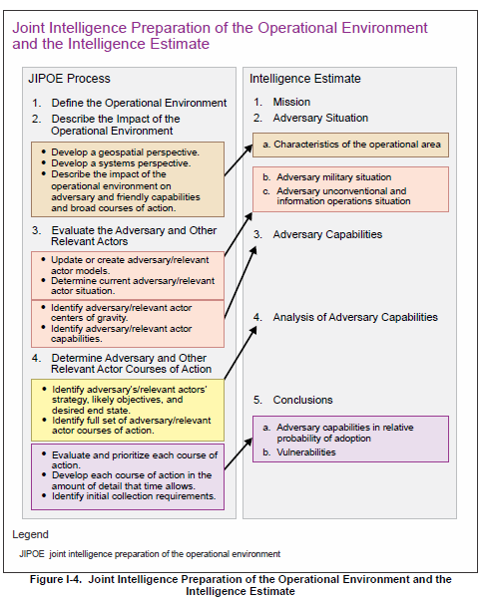

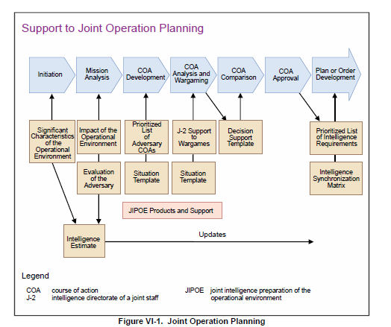

### Targeting

Development/refinement of JTL, recommend priorities to JFACC (SME on enemy), HVT, HPT from IPB

## Execution of the Air Campaign: Air Tasking Cycle

Intelligence collection during execution differs significantly from intelligence collection during planning. Intelligence collection support during the precrisis or warning phases requires developing a large volume of basic intelligence and preparation of broad-scope estimates needed to develop and analyze COAs. However, intelligence collection support during the execution phase must try to satisfy a much larger body of IRs in a significantly greater degree of detail. For example, the nature of the intelligence required by a MAGTF commander to decide if a noncombatant evacuation operation is feasible differs radically from the type and detail of intelligence required by the mission commander who will execute the operation.

Another major difference is the time available to satisfy IRs. In the execution phase there is a significant increase of time-sensitive IRs. Intelligence must often be developed in hours, minutes or even seconds. Success often depends on the ability to provide immediate answers to critical questions regarding threat force dispositions and intentions.

### Intelligence collection

#### Collection Management.

### Targeting

#### Targeting meeting

As part of the air tasking cycle JFACC and VIS may meet to conduct a targeting meeting.

Representatives from VIS and JFACC meet to synchronize their effort prior to the next ATO day. This can be conducted as a meeting but may also be conducted by providing the necessary information if time for a meeting is not possible. The targeting meeting can be conducted for each ATO day, or for any interval JFACC and VIS seem necessary (For example every other ATO day, or once for every phase). Ideally the targeting meeting start JFACCs stage 2 in the Air Tasking Cycle.

VIS will start the targeting meeting with presenting:

* Weather (forecast for next period)
* Current enemy situation (ground, air, IADS)
* BDA last ATO
* Eny ML/MD COA next ATOs (24-72 hours out) (Any changes to already briefed ML/MD COA)
* Current TST list
* Intelligence Requirements (intelligence gaps)

JFACC will then present the following information:

* Current friendly situation (Ground and air, including supporting assets and ordnance status) and planned operations next period.
* New guidance from higher CJTF (Directions and Guidance or orders received with guidance)
* Air requests from LCC or MCC.
* What assets are available for next ATO day (for targeting)

The information presented by both VIS and JFACC give everyone a good understanding of the enemy and friendly situation. The next item to be presented are JFACC and VIS nominations to the Joint Prioritized Target List for the next ATO. After the nominations VIS and JFACC will discuss and agree on a prioritized list of the targets. If there are any discrepancies, JFACC will have the final word. This will be the approved JPTL for next ATO cycle.

JFACC and VIS will also present and suggest a draft JPTL for the subsequent ATO cycle so both VIS and JFACC know what the likely priorities on the subsequent ATO cycle are.

Finally VIS and JFACC validated the time sensitive target list (make sure to add new TSTs if required, or remove TSTs if applicable).

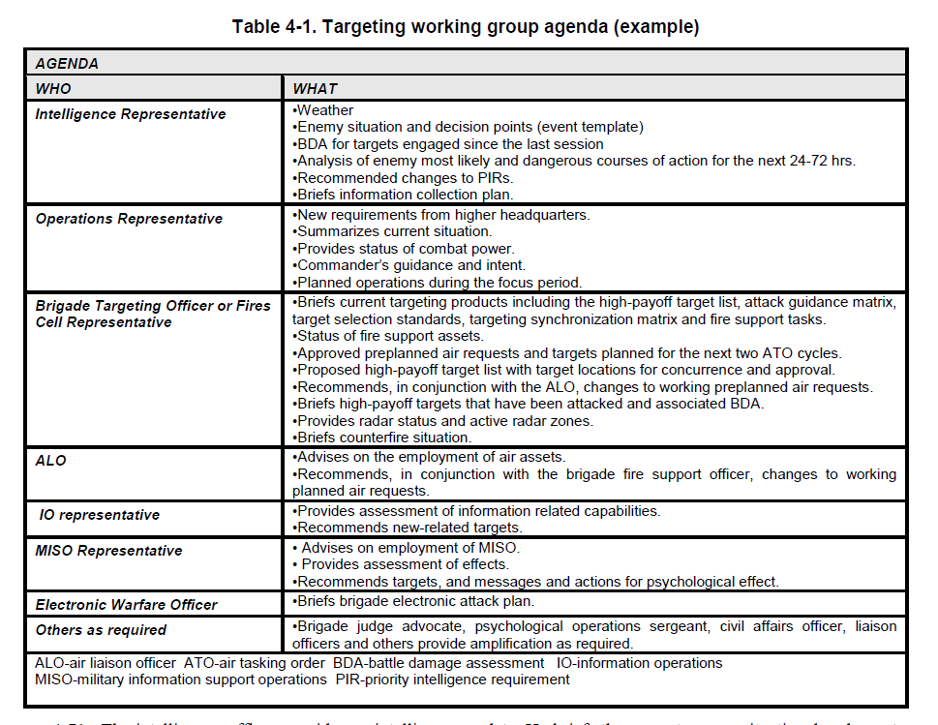

~~The intelligence officer provides an intelligence update. He briefs the current enemy situational and event~~

~~templates, current HVTs with locations, the commander’s critical information requirements, NAI, and an~~

~~overview of the current information collection plan. He provides BDA on targets previously engaged since the last~~

~~session of the targeting working group and the impact on the enemy COA. Most importantly, he prepares a~~

~~predictive analysis of the future enemy COA for the next 24-72 hours using the event template and a list of HVTs.~~

~~Finally, he briefs changes to the commander’s critical information requirements for review by the staff. The~~

~~intelligence officer’s products must be tailored to the designated time period to be discussed at the session but~~

~~generally include:~~

~~ The enemy situation.~~

~~ Review of the current information collection plans.~~

~~ BDA of targets engaged since the last session of the targeting working group or targeting board and~~

~~the impact on the enemy COA.~~

~~ An analysis of the enemy’s most probable COA and locations for the next 24 to 36 hours (possibly~~

~~projecting out 72 hours for targets subject to attack through ATO nominations).~~

~~ Recommended changes to the PIRs for the commander’s approval (if the commander is present), or~~

~~review by the staff.~~

~~4-72. The operations officer or his representative discusses any particular guidance from the commander,~~

~~changes to the commander's intent, and any changes since the last session of the targeting working group or targeting board to include task organization, requirements from higher headquarters to include recent fragmentary~~

~~orders and taskings, current combat power, the current situation of subordinate units, planned operations, and~~

~~maneuver assets and resources available. Finally, he informs the staff of the status of assets and resources~~

~~available for the targeting process. The operations officer’s products must be tailored to the designated time~~

~~period to be discussed at the session but generally include a friendly situation update that:~~

~~ Briefs any new requirements from higher headquarters since the last targeting working group or~~

~~targeting board session.~~

~~ Summarizes the current tactical situation.~~

~~ Informs on the status of available assets and resources (combat power).~~

~~ Briefs any particular guidance from the commander and changes to his intent.~~

~~ Briefs planned operations during the period covered by the targeting working group or targeting~~

~~board session.~~

~~4-73. The targeting officer or fires cell representative briefs fire support assets available including status of fire~~

~~support tasks, radars, CAS sorties available, status of naval surface fire support, ammunition availability, HPTL,~~

~~target selection standards, AGM, and targeting synchronization matrix.~~

~~4-74. The brigade fire support officer reviews approved planned air requests (alternatively, this may be briefed~~

~~by the Air Force ALO) for the period covered by the session and those planned for the next two ATO cycles—~~

~~normally done in 24-hour increments. In coordination with the Air Force ALO, he also recommends changes to~~

~~the working planned air requests and nominations for the planning cycle. He provides proposed targeting guidance~~

~~for the designated periods, and a new targeting synchronization matrix with the proposed list of high-payoff~~

~~targets and locations, for the staffs' concurrence and refinement.~~

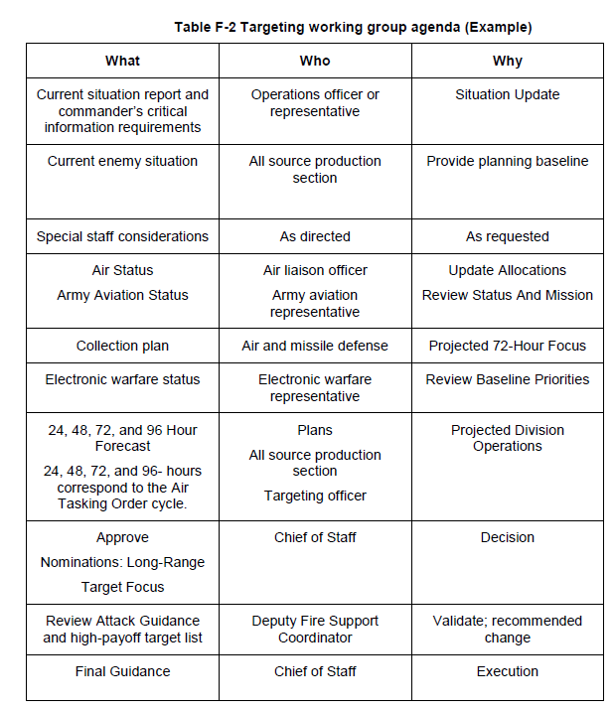

### Missions

The following missions can be tasked to support with dedicated intelligence collection in the 132nd:

* NTISR
* AR
* SCAR

### Products

Intelligence summary

Intelligence report

### INTELLIGENCE CONFIDENCE LEVELS IN ANALYTIC JUDGMENTS

VIS analysts should distinguish between what is known with confidence based on the facts of the situation and the OE and what are untested assumptions.

Intelligence can be facts that have been observed, or it can be a conclusion based on facts of

such certainty that it is considered to be knowledge. Intelligence can also be conclusions and

estimates deduced from incomplete sets of facts or induced from potentially related facts.

JFACC’s determination of appropriate objectives and operations may rest on knowing whether intelligence is “fact” or “assumption,” and knowing the particular logic used to develop an intelligence estimate, as well as knowing the confidence level VIS places on the provided intelligence and related analytic conclusions.

The following chart is intended to illustrate confidence in analytic judgments intelligence personnel may use to indicate a subjective judgment regarding the degree of confidence they place on the analytic conclusions contained in intelligence products. Confidence levels may be used by VIS to present analysis and conclusions to decision makers (JFACC, pilots and controllers) in a uniform, consistent manner.

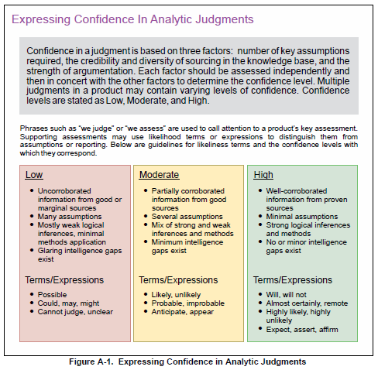

### Information Requirement

An IR is information “regarding the adversary and other relevant aspects of the operational environment that need to be collected and processed in order to meet the intelligence requirements of a commander.”2 Often written in the form of a question, a typical IR could be “What is the enemy’s capability and intent to attack friendly forces along Route Aggies?” To utilize limited collection assets in the most efficient manner, focusing intelligence collection and analysis prevents overwhelming the commander with information. The most important IRs are designated as commander’s critical information requirements (CCIRs) based on staff inputs and the commander’s scheme of maneuver. CCIRs are “critical to facilitating timely decision-making”, and may be categorized as either priority intelligence requirements (PIRs~~) or friendly force information requirements (FFIRs).~~~~3~~~~The IR above regarding Route Aggies would be selected by the commander as a CCIR if it would trigger key decisions such as the reallocation of forces or initiation of branches or sequels to the operations plan. Even if not selected as a CCIR, it still has merit for staff members and analysts to track in order to gain and maintain situation awareness, and could be designated as a CCIR at a later time~~

|  |
| --- |
| ~~Purposes of Air Reporting at the Tactical Level of War~~ |
| ~~1. Tactical threat warning~~ |
| ~~2. Mission planning~~ |
| ~~3. Targeting~~ |
| ~~4. Combat assessment~~ |
| ~~5. Threat assessment~~ |
| ~~6. Target imagery~~ |
| ~~7. Artillery and naval gunfire adjustment~~ |
| ~~8. Observation of ground battle areas, targets, or sections of airspace~~ |

|  |
| --- |
| ~~Purposes of Air Reporting at the Operational Level of War~~ |
| ~~1. Provide the intelligence information crucial to understanding a threat’s weaknesses in order to develop friendly courses of action~~ |
| ~~2. Help define the critical vulnerabilities of a threat’s national structure and military capabilities~~ |
| ~~3. Provide information on terrain; weather; and the threat’s size, movement, and situation~~ |
| ~~4. Provide threat assessment~~ |
| ~~5. Identify targets~~ |

|  |
| --- |
| ~~Purposes of Air Reporting at the Strategic Level of War~~ |
| ~~1. Locate threat centers of gravity and strategic targets~~ |
| ~~2. Warn of hostile intent and actions~~ |
| ~~3. Analyze threat deployment and employment~~ |
| ~~4. Assess damage to threat and friendly targets~~ |
| ~~5. Determine threat force structure~~ |
| ~~6. Identify the threat’s electronic order of battle~~ |
| ~~7. Provide threat indications and warning~~ |

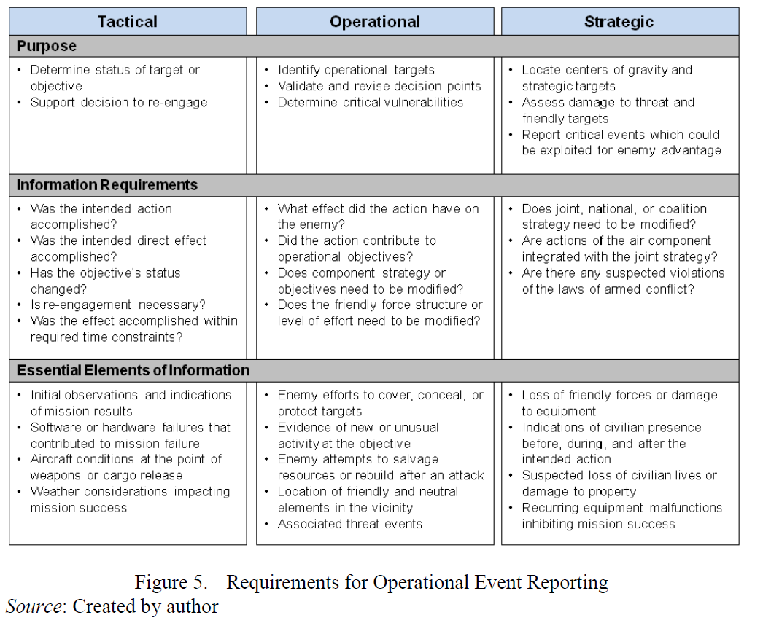

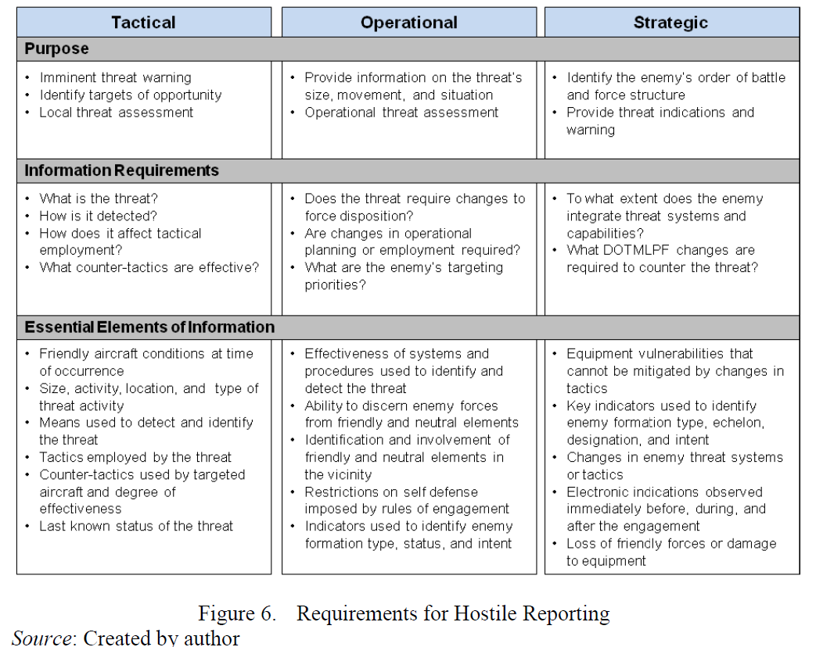

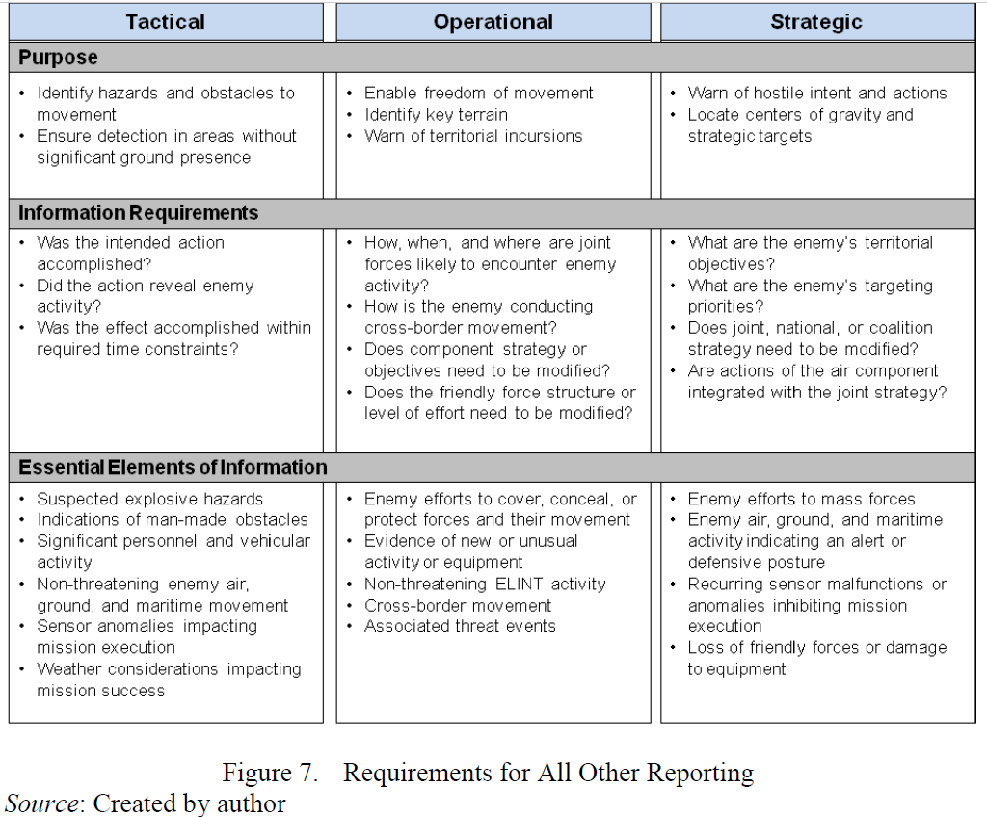

# Chapter 3: 132nd Flow

In the 132nd, the workflow for VIS is divided into two major parts. Part 1 is conducted prior to the first campaign mission and the output will be the Joint Air Operations Plan (JAOP). If the campaign goes over a long period of time (many events), then part 1 can also be used to update or refine the plan before a new phase in the campaign is started. Part 2 is the detailed planning conducted prior to each event and the main output is the Air Operations Directive (AOD) and Air Tasking Order (ATO).

**CAUTION:**

It is very easy to get too focused on products and creating the “correct” products and documents. The most important thing for JFACC is to plan and have a plan for the campaign as a whole and specifically for each event. The products are just a way of communicating the plan to everyone involved (Mission designer, AWACS controllers, JTACs and pilots). The best way to plan is to talk together while looking at a map, once plan or concept is agreed upon, then one can use the documents to convey the plan and necessary instructions to everyone involved. With the process explained below, the production of the actual product comes last, and it is important to do the first steps/stages without focusing on the output product (JAOP/AOD)

**NOTE:**

No one expects intelligence to be 100% accurate. There is uncertainty, conflicting information, inaccurate reporting, lack of reporting. VIS use their best judgement based on the facts and information available to provide the most accurate picture of the situation.

**NOTE:**

Real life will likely always prevent everyone from being committed 100% to the entire process every time. That is not a problem, and everyone should be prepared to be flexible and make decisions or have products that are not 100% respecting that this is a hobby for everyone and understand that people may have limited time to support from time to time.

## General concepts

When using JFACC and VIS construct in 132nd events the following guiding principles are effective:

* One ATO Day is divided into several events.
  + This is decided between mission designer and JFACC/VIS volunteers
  + Typically, one ATO day consist of minimum 2 events
  + The benefit this gives is that the products created for an event is still valid also for the next event and thus, events can be conducted at a more rapid pace. The only artificiality is that for event number two, JFACC will need to create a new ATO to facilitate for the signups on the actual date. But other products such as AOD, JPTL, ACO is still valid with the same information. For each ATO day JFACC/  
    VIS will be informed prior to planning that ATO day how many events the ATO day is divided into, and what time windows the events will cover (day and/or night).
* ATO day in a campaign is given the name D1 (for first day of campaign), D2 (second day), etc.
  + If more events are conducted on the same ATO day, then the event number for the day is added:
    - ATO Day 1, event 1: D1.1.
    - ATO Day 1, event 2: D1.2
    - ATO Day 2, event 3: D2.3.

## VIS Ambition 1

VIS ambition 1 is the most ambitious. This alternative includes full participation from VIS in both planning the campaign and during execution. In this alternative VIS will support both JFACC and pilots/controllers in their preparation and planning for the events.

See section 4.1 and section 4.2 for best practice on how to organize VIS.

## VIS Ambition 2

VIS ambition 2 is the middle ambition for VIS. This alternative includes full participation from VIS in the execution of the campaign only, and no VIS participation in the campaign planning. VIS will in this alternative support both JFACC and pilots/controllers in their preparation and planning for events.

See section 4.1 and section 4.2 for best practice on how to organize VIS.

## VIS Ambition 3

VIS ambition 3 is the lowest ambition for VIS. This alternative includes only support to pilots in execution of the event. VIS will in this ambition only focus on enemy air threat and SAM’s that are threats to pilots.

See section 4.1 and section 4.2 for best practice on how to organize VIS.

## Part 1 Planning: Air Campaign planning

The goal for VIS Air Campaign planning is to provide JFACC with the necessary understanding and situational awareness (SA) on the enemy and situation for JFACCs planning of the air campaign. VIS supports JFACC air campaign planning using the VIS Intelligence Preparations of the Battlespace (IPB) process that consist of four steps:

Step 1: Define the Battlespaces Environment

Step 2: Describe the Battlespace`s Effects

Step 3: Evaluate the Enemy

Step 4: Determine Enemy Course of Actions (COA)

VIS may start planning at the same time as JFACC, or VIS may start earlier than JFACC in planning. The VIS IPB process is connected to JFACC Air Campaign planning in the following way:

* VIS IPB Step 1 and 2 are an input to JFACC Air Campaign Planning step 1 (Operational Environment Research).
* VIS IPB Step 1-3 are inputs to JFACC Air Campaign Planning step 2 (Center of Gravity Identification).
* VIS IPB step 1-4 are inputs to JFACC Air Campaign Planning step 3 (Objective Determination) and step 4 (Strategy identification).

**So, while there are a lot of work and time-consuming tasks in the Intelligence Preparations of the Battlespace (IPB), it will pay dividends when it is completed before the start of the air tasking cycle. The workload is reduced between each planned event and events can be conducted at a higher pace as VIS have a deep understanding of the enemy and the battlespace.**

During the various steps, intelligence reports can be produced on specific topics (For example treat from enemy a-a missiles such as MAR distances and homing and most effective countermeasures or maneuvers, threat from enemy aircrafts, threat from enemy SAMs). This are basic intelligence based on the equipment and any available information (VID Intrep Generic ground force structure and VID Intrep generic air force structure) adjusted for the current campaign so JFACC and participants in the campaign better understand the threats they are facing.

### Step 1: Define the Battlespaces Environment

In step 1 VIS decide what areas they should focus on (which countries and how far out to sea). Typically, this will be the enemy country, and neighboring countries in addition to any potential alliance partners. This area will be defined as the area of responsibility (AOR).

### Step 2: Describe the Battlespace`s Effects

In this step VIS will look at the map (using CombatFlite) on the AOR and look at important features that will aid in subsequent steps:

* Time and distance (from various airbases, at different speeds)
* Time and distance (from bases or major cities following major roads)
* Identify blind zones (for enemy SAM/EW radars). A detailed stud of the terrain to see opportunity and limitations.
* Identify mobility corridors for enemy ground forces
* Identify sea lines of communications (seaports)
* Identify key terrain that may be important for the enemy or friendly forces

### Step 3: Evaluate the Enemy

In this step VIS will study the enemy and its order of battle. Input to this step are VID intrep`s provided for the situation/campaign and VID basic intelligence (INTREP VID B-001 Generic Ground Force Structure and INTREP VID B-002 Generic Air Force Structure ).

VIS will start with analyzing and identifying the enemy’s center of gravity (COG).

VIS will start with determining the current enemy situation through an analysis of relevant order of battle inputs in VID intrep`s and basic intelligence. How are the enemy forces positioned in the AOR is one of the key answers that come out of this sub-step. Another output is the definitive and current adversary order of battle (for example in a spreadsheet) for updating during the execution phase of the campaign.

VIS will then create or update available threat models. This can be range rings for SAMs, artillery, rocket artillery, SCUD`s etc. In addition, this can be what distances are various enemy aircraft able to fly from their bases (playtime), what the A-A missile threats are (DOR/MAR/Homing/what kind of countermeasures and maneuvers work best to defeat missiles). These threat models should be presented in a graphical form, using for example CombatFlite as background.

VIS will then combine the information and provide an assessment of the enemy’s current capabilities, strengths, and weaknesses. In addition, VIS will identify enemy high value targets (HVT) and list the priority of these.

### Step 4: Determine Enemy Course of Actions (COA)

In this step VIS will identify and develop the enemy most likely and most dangerous course of action (ML/MD COA). The purpose is to identify the enemy COAs so they can be exploited to accomplish the friendly mission. Information derived and products produced while performing steps one through three are fused together to project what the adversary is likely to do given the environment and his capabilities.

VIS will also identify high value targets (HVT) and other targets that are valuable to the enemy in executing the COAs and nominate for attack those targets that will achieve the chosen friendly COA and objectives.

VIS will identify any collection requirements that monitor indicators that can inform VIS on which COA the enemy are using (or if there will be a shift from one COA to another COA).

Once step 4 is completed, the outputs from all steps can be combined into one report that will aid JFACC in their planning of the air campaign. Intelligence from the various steps will also aid VIS in the execution phase of the campaign.

## Part 2 Execution: Air Tasking Cycle (per ATO day)

Throughout the process VIS members follow overall guidance and priorities given by JFACC in JAOP and AOD.

### Per event

After an 132nd event VIS follow the intelligence cycle in the steps listed below. Step 1-3 focus on the previous ATO day, while step 4-5 focuses on the next ATO day.

#### Step 1 Processing:

All relevant information is registered in the VIS intelligence log and is organized for further production of intelligence. Pictures (screenshots), BDA report, observations, radar, RWR information, additional intelligence (VID) are all registered in the log for easier use during step 2 Production. All registered items are given a reference number to keep track and avoid double reporting. In addition to the intelligence log, all entries are also exported to a CombatFlite file. This make it easier for VIS members to see connections and how the various entries are related to each other and to enemy activity in step 2.

TO DO:

* FIND SOMEONE TO MAKE A FUNCTION FOR AUTOMATICLY CREATING THIS LOG FROM AAR OR INTEL REPORTING (EITHER FROM CURRENT WEBSITE AAR, OR CREATE NEW INPUT FOR INTELREPORTING). WITH THIS FUNCTION VIS SHOULD ALSO HAVE THE OPPERTUNTY TO CREATE MANUAL ENTRIES IN THE LOG, FOR EXAMPLE FROM VID INTELLIGENCE REPORTS
* NEED TO FIND SOMEONE TO MAKE A FUNCTION TO EXPORT FROM THE LOG TO COMBATFLITE TO AVOID UNNECESSARY TIME FOR PLOTTING FOR VIS MEMBERS)
* **ENDSTATE IS TO AVOID VIS MEMBERS NEEDING TO SPEND MUCH TIME DOING THIS STEP. FOCUS SHOULD BE ON THE REST OF THE PROCESS**.

#### Step 2 Analysis and Production

VIS members use all available information from last ATO day, previous events, intelligence reports and background intelligence reports and create a summary of intelligence after that ATO day. The intelligence summary may consist of:

* BDA from last ATO day
* Current enemy ground disposition (facts+assessment)
* Current enemy air disposition (facts+assessment)
* Current enemy air defense disposition (facts+assessment)
* Assessed enemy most likely course of action (ML COA) and most likely dangerous course of action (MD COA) for next 24-48 hours (next event), and more long-term (next phases)
* Recommendations
* Intelligence gaps/Intelligence requirements

In addition to the intelligence summary, VIS may produce additional intelligence reports (INTREP) on specific subjects. For example, going more into detail about capabilities, assessments on topics such as air defense, enemy air forces, enemy high value units, specific area, enemy course of actions etc.

NOTE: Focus is on understanding the enemy and the situation doing the analysis of available information and intelligence. The products are just a way of conveying the information. Do not feel restricted by any template or specific product. Convey the intelligence in any way suitable.

#### Step 3 Dissemination

Once VIS have created an intelligence summary of the last ATO day, the report is published and made available for both JFACC and all participants in the campaign in a suitable form. The intelligence and understanding of the situation and the enemy that VIS have can be either a written report or can be presented verbally at briefings. The product itself is not what is important. The product is just a way to convey the information in the most efficient way.

#### Step 4 Planning and direction

As a preparation for the next event, VIS members look at overall guidance in JAOP and AOD and look at their current intelligence gaps and based on this identify intelligence requirements that are presented to JFACC. JFACC will include these intelligence requirements into their air tasking cycle (stage 2) and if prioritized flights will be tasked to collect information to answer the intelligence requirements. The intelligence gaps can also be forwarded to VID (mission designer) as a request for information (RFI).

With all intelligence produced and disseminated during step 3 and 4 VIS have the necessary intelligence and SA to support JFACC for the next event. During this step VIS and JFACC therefore may conduct a “targeting meeting”.

##### Targeting meeting

Representatives from VIS and JFACC meet to synchronize their effort prior to the next event. This can be conducted as a meeting but may also be conducted by providing the necessary information if time for a meeting is not possible. The targeting meeting can be conducted for each ATO day, or for any interval JFACC and VIS seem necessary (For example every other ATO day, or once for every phase). Ideally the targeting meeting start JFACCs stage 2 in the Air Tasking Cycle.

See section 2.8.2.1 for detailed information about Targeting meeting.

#### Step 5 Collection

In step 5, VIS have no active role.

During the next ATO day, participants collect necessary information based on the intelligence requirements

### Special topics

VIS may also work independently of the air tasking cycle if working on special topics such as: “*Will state X intervene in the conflict, and if so, when and how will they intervene*” or “*What is the status of state X chemical weapon program*”. All intelligence gaps and collection should be tied into the air tasking cycle, but the reports may be presented only once in the campaign either before a phase change, or when it is needed to answer important intelligence gaps for JFACC before deciding what to do.

When working with special topics, VIS members follow the same intelligence steps as listed in the air tasking cycle but will typically start with planning and direction before collection is done. Once VIS have received enough information VIS then process the information before analyzing the data and producing intelligence. The cycle can then be repeated how many times as necessary until VIS have enough for a product (either verbally or written) that can be disseminated.

# VIS organization

Best practice for VIS is:

## Air campaign planning

It is recommended that one member of the VIS team is in charge, as it will be easier to maintain overall understanding and making sure the entire team gets through the process. To get a through and good understanding of the enemy and the situation it is recommended that all VIS members conduct the steps in the IPB without breaking out in various teams. This will give the best overall understanding that will aid during the air tasking cycle.

## Air tasking cycle:

For the execution of the campaign through the air tasking cycle it is recommended that VIS members organize themselves in teams (based on interest and who people like to work with)

It is recommended that various VIS members organize themselves in teams:

* Air/Air defense (IADS)
  + This team will focus on the enemy’s air forces, their SAM systems or IADS. This team may keep an updated orbat and BDA over enemy air assets and the status of IADS
  + There is a potential overlap with the team working with the ground picture, as the enemy ground forces also have SAM’s in their orbat. But these are systems primarily supporting the enemy’s ground forces so there may be need for some coordination with the ground team on who is responsible for the SAMs
  + This team is typically supporting pilots/controllers in OCA/DCA/SEAD operations, while also support Air Interdiction and Long Range strikes.
  + This team also function as a subject matter expert for JFACC on enemy Air and Air defense.
* Ground (Enemy ground forces)
  + This team will focus on the enemy’s ground forces, their position and activity
  + This team will try to identify locations for enemy high value targets such as headquarters, artillery, logistics
  + This team will try to anticipate what the ground forces will be doing in the future
  + This team is typically supporting pilots/controllers in CAS/AR missions
  + This team also function as a subject matter expert for JFACC on enemy ground forces.
* Targeting/Overall scenario
  + This team will focus on the “big picture” and keep track of other countries and what they are doing
  + This team also focuses on the campaign and its objectives, and is thus the best suited to focus on the air interdiction campaign and the targeting for the overall campaign
  + This team also try to keep track of the enemy ML and MD COA, and can give recommendation if the enemy switch from a ML to a MD COA so JFACC can make necessary changes.
  + This team is typically mostly focused on supporting JFACC.

# ANNEX

## Annex 1: Worksheet for understanding objectives

Objective (XX)

Identify the enemy activity to be affected (**WHAT** do we want to do?)

Answer:

Identify the target system(s) performing the activity (Against **WHOM?)**

Answer:

Identify the specific location where enemy activity should be modified (**WHERE** do we want to affect the enemy activity)

Answer:

Determine the opportune time and duration to impact the enemy (**WHEN** and for **HOW LONG** do we want to impact the objectives?)

Answer:

Identify logical, available assets that can reach the objective target(s) within time constraints (**HOW** do we want to reach the objective).

Answer:

State attainable, quantifiable criteria against which effectiveness/success will be measured (**TO WHAT DEGREE** do we want to reach the objective)

Answer:

Perform cost analysis to estimate the cost versus potential benefit. (**HOW MUCH** will it cost to reach the objective, and is it **WORTH** it?)

Answer:

Check the objective against all known guidance. (**WHY** do we want to reach the objective?)

Answer:

### Example

Objective 1: Destroy Country X capability of using weapons of mass destruction

Identify the enemy activity to be affected (**WHAT** do we want the enemy to do?)

**Answer:**

* Stop production of chemical weapons
* Unable to deliver WMD toward friendly countries.

Identify the target system(s) performing the activity (Against **WHOM?)**

**Answer:**

* 361st SCUD Battalion
* Chemical weapon storage in location A
* Chemical weapon storage location B
* Chemical weapon research facility A
* Chemical weapon production facility B

Identify the specific location where enemy activity should be modified (**WHERE** do we want to affect the enemy activity)

**Answer:**

* 361st SCUD Battalion deployed to Desert Y
* Chemical weapon production facility B located in city X.

Determine the opportune time and duration to impact the enemy (**WHEN** and for **HOW LONG** do we want to impact the objectives?)

**Answer:**

* WMD delivery means: As soon as possible
* Chemical weapon factory B: As soon as possible, out of action for 6 months.

Identify logical, available assets that can reach the objective target(s) within time constraints (**HOW** do we want to reach the objective).

**Answer:**

* AR mission to locate and destroy 361st SCUD Battalion in desert Y
* Strike mission against chemical weapon production factory

State attainable, quantifiable criteria against which effectiveness/success will be measured (**TO WHAT DEGREE** do we want to reach the objective)

**Answer**:

* 361st SCUD BN: 8 of 8 SCUD TEL destroyed
* Chemical weapon production factory: Entire building collapsed

Perform cost analysis to estimate the cost versus potential benefit. (**HOW MUCH** will it cost to reach the objective, and is it **WORTH** it?)

**Answer:**

* AR mission against 361st SCUD BN in desert Y: Low threat, single flights can be tasked to search and destroy SCUD
  + Destroying the SCUD BN will eliminate the threat from chemical weapons from country X as without them, Country X will have no means of delivering the chemical weapons against friendly countries.
* Strike mission against chemical weapon production factory: Heavily defended city, air defenses need to be attacked and suppressed prior to any attack. High risk mission due to threat large complex, so many aircrafts needed. A large package needed.
  + Destruction of the factory prevents a critical chemical needed for the weapons of mass destruction to work, and if the factory is destroyed, country X will not be able to produce any more chemical weapons

Check the objective against all known guidance. (**WHY** do we want to reach the objective?)

**Answer:**

Prevent weapons of mass destruction of being used against friendly forces.

## Annex 4: Target priorities

Priority A

* The target is essential for mission success in support of current objectives (or is a designated a Time Sensitive Target (TST).
* It is crucial to the overall success of the operation.
* It will have immediate and compelling effects.
* Its timeliness as an urgent target may not exist in the future.
* If not targeted, negative consequences may seriously jeopardize future CJTF operations

Priority B:

* Targets have substantial, but not immediate impact on the battle.
* The cascading effects this target provides may not be realized in the future.
* If not targeted on this ATO, a significant level of effort may be required later.
* If not targeted, negative consequences may significantly hamper CJTF operations.

Priority C:

* It will contribute to the battle, but it is not critical to mission success.
* It will further the success of the operation.
* It will eventually require targeting due to JFC future plans.
* If not targeted on this ATO, negative consequences will probably not impede operations.

Priority D:

* Target of opportunity if:
  + A) Other targets not suitable for this ATO.
  + B) As a backup target
* It will have minor contributions to the operation.
* It may be required for targeting, but is not time critical.
* If not targeted, no negative consequences

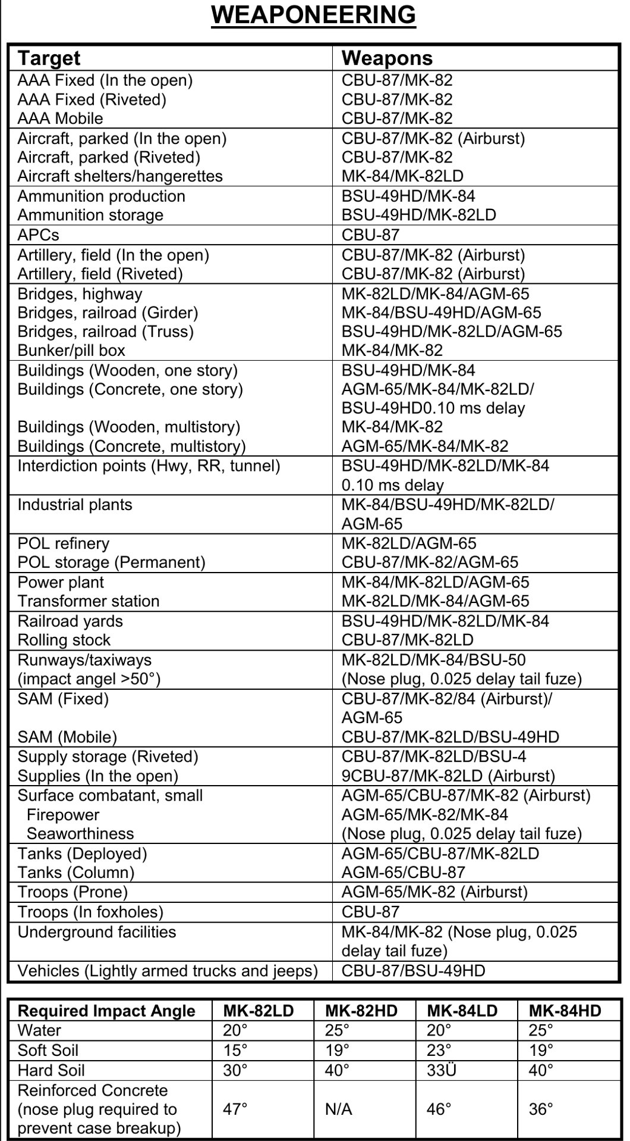

## Annex 6: Aircraft to tasking

A table with suggested tasking for the various aircrafts

Plus and minus with each aircraft per tasking?

## Effects

Terms that are used to describe the desired effects include:

● **Deceive.** Military leaders attempt to mislead threat decision makers by manipulating their

understanding of reality.

● **Defeat.** *Defeat* is a tactical mission task that occurs when an enemy force has temporarily or

permanently lost the physical means or the will to fight. The defeated force’s commander is

unwilling or unable to pursue that individual’s adopted course of action, thereby yielding to the

friendly commander’s will and can no longer interfere to a significant degree with the actions of

friendly forces. Defeat can result from the use of force or the threat of its use (FM 3-90-1).

Defeat manifests itself in some sort of physical action, such as mass surrenders, abandonment of

positions, equipment and supplies, or retrograde operations. A commander can create different

effects against an enemy to defeat that force. For example a commander’s employment of field

artillery fires to attack an enemy force may result in the enemy no longer having sufficient

**1-2 ATP 3-60 7 May 2015**

**Target Guidelines and Philosophy**

personnel, weapons systems, equipment, or supplies to carry out its mission. Likewise the

delivery of massed, synchronized and intense fires can cause enemy personnel to lose the will to

continue to fight.

● **Degrade*.*** To degrade is to reduce the effectiveness or efficiency of a threat.

● **Delay.** To *delay* is to slow the time of arrival of enemy forces or capabilities or alter

the ability of the enemy or adversary to project forces or capabilities. (FM 3-09)

When enemy forces are delayed, friendly forces gain time. For delay to have a major impact the

enemy must face urgent movement requirements or the delay must enhance the effect(s) of

friendly operations. When delayed enemy forces mass behind a damaged route segment a more

concentrated set of targets and a longer period of exposure to friendly fires results.

● **Deny.** An example of deny is to destroy the threats communications equipment as a means of

denying his use of the electromagnetic spectrum; however, the duration of denial will depend on

the enemy’s ability to reconstitute. *Denial operations* are actions to hinder or deny the enemy

the use of space, personnel, supplies, or facilities (FM 3-90-1).

● **Destroy.** *Destroy* is a tactical mission task that physically renders an enemy force combatineffective

until it is reconstituted. Alternatively, to destroy a combat system is to damage it so

badly that it cannot perform any function or be restored to a usable condition without being

entirely rebuilt. (FM 3-90-1).

● **Destruction**. *Destruction* is 1. In the context of the computed effects of field artillery fires,

destruction renders a target out of action permanently, or ineffective for a long period of time,

producing 30-percent casualties or materiel damage. 2. A type of adjustment for destroying a

given target (FM 3-09).

● **Disrupt*.*** *Disrupt* is 1. A tactical mission task in which a commander integrates direct and

indirect fires, terrain, and obstacles to upset an enemy’s formation or tempo, interrupt the

enemy’s timetable, or cause enemy forces to commit prematurely or attack in a piecemeal

fashion (FM 3-90-1). 2. An obstacle effect that focuses fire planning and obstacle effort to cause

the enemy force to break up its formation and tempo, interrupt its timetable, commit breaching

assets prematurely, and attack in a piecemeal effort (FM 3-90-1).

● **Divert.** To divert is to turn aside or from a path or course of action. A *diversion* is the act of

drawing the attention and forces of an enemy from the point of the principal operation; an attack,

alarm, or feint that diverts attention (JP 3-03). Diversion causes enemy forces to consume

resources or capabilities critical to enemy operations in a way that is advantageous to friendly

operations. Diversions draw the attention of enemy forces away from critical friendly operations

and prevent enemy forces and their support resources from being employed for their intended

purpose. Diversions can also cause more circuitous routing along lines of communication,

resulting in delays for enemy forces. An option for field artillery employment in support of a

commander’s diversion is to use high explosive fires to encourage an enemy to adopt a different

route.

● **Exploitation.** *Exploitation* is an offensive task that usually follows a successful attack and is

designed to disorganize the enemy in depth (ADRP 3-90).

● **Interdict.** *Interdict* is a tactical mission task where the commander prevents, disrupts, or delays

the enemy’s use of an area or route (FM 3-90-1).

● **Neutralize*.*** *Neutralize* is a tactical mission task that results in rendering enemy personnel or

materiel incapable of interfering with a particular operation (FM 3-90-1).

● **Neutralization.** *Neutralization* in the context of the computed effects of field artillery fires,

neutralization renders a target ineffective for a short period of time, producing 10-percent casualties or

materiel damage (FM 3-09).

● **Suppress.** *Suppress* is a tactical mission task that results in temporary degradation of the

performance of a force or weapons system below the level needed to accomplish the mission

(FM 3-90-1). Also see suppressive fire and suppression. (FM 3-09)